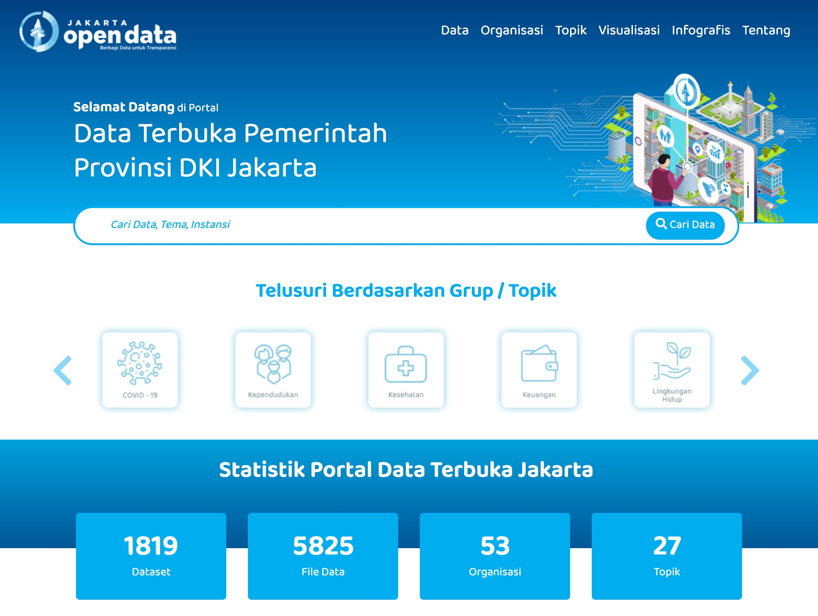Open Data Jakarta V2.0

Dokumentasi Sistem dan Rancangan Perangkat Lunak Open Data Jakarta
BASELINE SISTEM
Nama Sistem : Open Data Jakarta Versi : 2.0
Bahasa Pemrograman : PHP 7.3.9 Basis data : Mysql 8.0
Framework : Codeigniter v3

Tim Pengembang
Penanggung Jawab : Harry Sanjaya Pengendali : Ryan Aldiansyah Akbar Pelaksana : 1. M Rheza Muztahid
2. M Robbi Nugraha
3. Mirza Rakapradipta

Seksi Pelayanan Informasi Publik Bidang Informasi Publik Diskominfotik
Pemerintah provinsi DKI Jakarta

2020 | Dinas Komunikasi, Informatika, dan Statistik Pemprov DKI Jakarta

Daftar Isi

DAFTAR ISI ................................................................................................................................................. I DAFTAR GAMBAR .................................................................................................................................. III DAFTAR TABEL ...................................................................................................................................... IV DAFTAR LAMPIRAN .............................................................................................................................. IV
1. TENTANG OPEN DATA JAKARTA ................................................................................................... 1

1.1 DASAR HUKUM OPEN DATA JAKARTA .............................................................................................................. 1
1.2 KEBIJAKAN SATU DATA & OPEN DATA ............................................................................................................ 2

2. LATAR BELAKANG OPEN DATA V2.0 ............................................................................................ 2

3. TUJUAN & SPESIFIKASI FUNGSI ...................................................................................................... 3

4. SUMBER DAYA ..................................................................................................................................... 4

4.1 KEBUTUHAN PERANGKAT KERAS, JARINGAN, DAN KEAMANAN ..................................................................... 4
4.2 KEBUTUHAN SUMBER DAYA MANUSIA .............................................................................................................. 4
4.2.1 Sumber Daya Teknis ................................................................................................................................... 5
4.2.2 Sumber Daya Non-Teknis ......................................................................................................................... 5

5. TIMELINE PENGEMBANGAN SISTEM ............................................................................................. 7

6. DESAIN ARSITEKTUR & MIGRASI DATA ...................................................................................... 8

6.1 FLOWCHART .......................................................................................................................................................... 8
6.2 USE CASE DIAGRAM .............................................................................................................................................. 9
6.3 DATABASE ............................................................................................................................................................ 11
6.4 MIGRASI DATA .................................................................................................................................................... 12
6.5 ARSITEKTUR FRAMEWORK ................................................................................................................................ 13

7. BACK-END CLASS & FUNCTIONS ..................................................................................................... 15

7.1 APPLICATION/CONTROLLER/C_SYS_DATASET .............................................................................................. 16 index() ....................................................................................................................................................................... 16 data_pipe() ............................................................................................................................................................. 17 data_pipe_delete() ............................................................................................................................................... 17 insert_edit() ............................................................................................................................................................ 17 req_delete() ............................................................................................................................................................ 17 confirm_delete() ................................................................................................................................................... 17 status() ..................................................................................................................................................................... 17 list_delete() ............................................................................................................................................................. 17 dbcheck_uri() ......................................................................................................................................................... 17 check_uri() .............................................................................................................................................................. 17 metadata_insert_update() ............................................................................................................................... 17 view_res_by_id() ................................................................................................................................................... 18 resource_create() ................................................................................................................................................. 18 sort_res() ................................................................................................................................................................. 18 resource_update() ............................................................................................................................................... 18 history() ................................................................................................................................................................... 18

data_uploaded() ................................................................................................................................................... 18 update_res() ........................................................................................................................................................... 18 report() ..................................................................................................................................................................... 18 array_to_csv_download() ................................................................................................................................. 18 createLog() ............................................................................................................................................................. 18
7.2 APPLICATION/CONTROLLER/C_SYS_DOWNLOAD ......................................................................................... 19
index() ....................................................................................................................................................................... 19
file() ........................................................................................................................................................................... 19
7.3 APPLICATION/CONTROLLER/C_SYS_ORGANIZATION .................................................................................... 20 index() ....................................................................................................................................................................... 20 viewbyid() ............................................................................................................................................................... 20 create() ..................................................................................................................................................................... 20 update() ................................................................................................................................................................... 20 view_img() .............................................................................................................................................................. 20
7.4 APPLICATION/CONTROLLER/C_SYS_PROFILE ................................................................................................ 21
index() ....................................................................................................................................................................... 21 password() .............................................................................................................................................................. 21 log() ........................................................................................................................................................................... 21
7.5 APPLICATION/CONTROLLER/C_SYS_SIGN ...................................................................................................... 22 index() ....................................................................................................................................................................... 22 randBackground() .............................................................................................................................................. 22 logout() .................................................................................................................................................................... 22
7.6 APPLICATION/CONTROLLER/C_SYS_TOPIC .................................................................................................... 23 index() ....................................................................................................................................................................... 23 viewbyid() ............................................................................................................................................................... 23 create() ..................................................................................................................................................................... 23 update() ................................................................................................................................................................... 23 view_img() .............................................................................................................................................................. 23
7.7 APPLICATION/CONTROLLER/C_SYS_USER ...................................................................................................... 24
index() ....................................................................................................................................................................... 24 viewbyid() ............................................................................................................................................................... 24 create() ..................................................................................................................................................................... 24 update() ................................................................................................................................................................... 24
7.8 APPLICATION/CONTROLLER/API_ODJ ............................................................................................................. 25
getalldataset_get() .............................................................................................................................................. 25 create_excel() ........................................................................................................................................................ 25 create_excel_dataset() ....................................................................................................................................... 25 create_excel_dataset_id() ................................................................................................................................. 25 create_excel_resource() ..................................................................................................................................... 25 create_excel_resource_delete() ...................................................................................................................... 25 create_excel_topik() ............................................................................................................................................ 25 create_excel_organisasi() ................................................................................................................................. 25 api_all_dataset_get() .......................................................................................................................................... 25 api_all_resource_get() ........................................................................................................................................ 26 api_all_resource2_get() ..................................................................................................................................... 26 createJson() ............................................................................................................................................................ 26 exceltojson_get() .................................................................................................................................................. 26 status_verifikasi_bappeda_get() .................................................................................................................... 26 api_status_verifikasi_bappeda_get() ........................................................................................................... 26

getdataod_post() .................................................................................................................................................. 26
getdataodall_post() ............................................................................................................................................ 26
7.9 APPLICATION/CONTROLLER/PUBLIC_HOME ................................................................................................. 27 index() ....................................................................................................................................................................... 27 dataset() .................................................................................................................................................................. 27 download_file() ..................................................................................................................................................... 27 organization() ....................................................................................................................................................... 28 group() ..................................................................................................................................................................... 28 visualisasi() ............................................................................................................................................................ 28 Infografis() ............................................................................................................................................................. 28 tentang() ................................................................................................................................................................. 28 saran_dataset() .................................................................................................................................................... 28 img() .......................................................................................................................................................................... 28 str_replace() ........................................................................................................................................................... 29 get_dataset() .......................................................................................................................................................... 29 get_organization() .............................................................................................................................................. 29 get_group() ............................................................................................................................................................. 29 get_organization_by() ....................................................................................................................................... 29 get_topic_by() ........................................................................................................................................................ 29 get_tag_by() ............................................................................................................................................................ 30 count_view_download() .................................................................................................................................... 30 formatSizeUnits() ................................................................................................................................................ 30 banner() ................................................................................................................................................................... 30 summary() .............................................................................................................................................................. 30 totalVisitor() .......................................................................................................................................................... 30

8. FRONT-END FILES ............................................................................................................................. 30

9. ROUTING LINK TO FUNCTION ....................................................................................................... 31

10. LIBRARIES, SYSTEM REQUIREMENT, & INSTALASI ............................................................... 34

10.1 LIBRARIES ......................................................................................................................................................... 34
10.2 SYSTEM REQUIREMENT ................................................................................................................................... 36
10.3 INSTALASI ......................................................................................................................................................... 36

Daftar Gambar

GAMBAR 1 FLOWCHART SISTEM OPEN DATA JAKARTA V2.0 ................................................................................... 8 GAMBAR 2 USE CASE DIAGRAM OPEN DATA JAKARTA V2.0 ..................................................................................... 9 GAMBAR 3 POINT EXTEND USECASE OPEN DATA JAKARTA V2.0 ............................................................................ 10 GAMBAR 4 ARSITEKTUR DESAIN BASIS DATA OPEN DATA JAKARTA V2.0 ............................................................ 11 GAMBAR 5 ARSITEKTUR FRAMEWORK OPEN DATA JAKARTA V2.0 ....................................................................... 14 GAMBAR 6 DAFTAR CLASS PADA SISTEM OPEN DATA JAKARTA V2.0 ................................................................... 15 GAMBAR 7 SYS DATASET VIEW ..................................................................................................................................... 16 GAMBAR 8 SYS DOWNLOAD VIEW ................................................................................................................................ 19 GAMBAR 9 SYS ORGANIZATION VIEW .......................................................................................................................... 20 GAMBAR 10 SYS PROFILE VIEW .................................................................................................................................... 21 GAMBAR 11 SYS SIGN VIEW .......................................................................................................................................... 22 GAMBAR 12 SYS TOPIC VIEW ........................................................................................................................................ 23 GAMBAR 13 SYS USER VIEW ......................................................................................................................................... 24

GAMBAR 14 PUBLIC HOME VIEW ................................................................................................................................. 27
GAMBAR 15 STRUKTUR HMTL PADA FRONT-END VIEW ........................................................................................ 31

Daftar Tabel

TABEL 1TIMELINE PROYEK PEMBANGUNAN SISTEM OPEN DATA JAKARTA V2.0 ................................................. 7 TABEL 2 KUMPULAN TABEL DALAM DATABASE SISTEM OPEN DATA JAKARTA V2.0 .......................................... 12 TABEL 3 FUNGSI-FUNGSI PADA C_SYS_DATASET ....................................................................................................... 16 TABEL 4 FUNGSI-FUNGSI PADA C_SYS_DOWNLOAD .................................................................................................. 19 TABEL 5 FUNGSI-FUNGSI PADA C_SYS_ORGANIZATION ............................................................................................ 20 TABEL 6 FUNGSI-FUNGSI PADA C_SYS_PROFILE ........................................................................................................ 21 TABEL 7 FUNGSI-FUNGSI PADA C_SYS_SIGN ............................................................................................................... 22 TABEL 8 FUNGSI-FUNGSI PADA C_SYS_TOPIC ............................................................................................................ 23 TABEL 9 FUNGSI-FUNGSI PADA C_SYS_USER .............................................................................................................. 24 TABEL 10 FUNGSI-FUNGSI PADA API_ODJ ................................................................................................................... 25 TABEL 11 FUNGSI-FUNGSI PADA PUBLIC_HOME ........................................................................................................ 27 TABEL 12 ROUTING LINK TO FUNCTION OPEN DATA JAKARTA V2.0 .................................................................... 31 TABEL 13 CSS & JS LIBRARIES YANG DIGUNAKAN PADA OPEN DATA JAKARTA V2.0 ....................................... 34

Daftar Lampiran

LAMPIRAN 1 KODE PROGRAM RESTRUKTURISASI DATABASE .................................................................................. 37
LAMPIRAN 2 KODE PROGRAM PEMINDAHAN FILE BERKAS ...................................................................................... 42

1. TENTANG OPEN DATA JAKARTA

https://data.jakarta.go.id/ (Open Data Jakarta) adalah Portal Data Terpadu Pemerintah Provinsi DKI Jakarta yang menyajikan data-data dari seluruh Satuan dan Unit Kerja di Pemerintah Provinsi DKI Jakarta. https://data.jakarta.go.id/ lahir sebagai cita-cita Pemerintah Provinsi DKI Jakarta untuk menyediakan satu basis data pembangunan yang akurat, terbuka, terpusat dan terintegrasi, sesuai dengan amanat Peraturan Gubernur Provinsi DKI Jakarta Nomor 181 Tahun 2014.
Open Data Jakarta menyediakan data dalam format yang mudah dicari, diakses serta digunakan kembali, dengan harapan publik/masyarakat pengguna portal dapat memanfaatkan data yang telah tersedia serta menciptakan inovasi dan peran serta dalam membangun kota Jakarta dan negara Indonesia menjadi lebih baik. Harapannya, data.jakarta.go.id dapat menjadi Portal Data Terpadu menjadi Portal Data yang akurat, mutakhir, terbuka, terintegrasi, lengkap, akuntabel, dinamis, handal, valid, mudah diakses dan berkelanjutan, dan dapat menyajikan data dan informasi yang dibutuhkan oleh masyarakat serta memenuhi hak publik sebagai bentuk penerapan e-government dalam rangka mewujudkan tata kelola pemerintahan yang transparan dan akuntabel.
Sesuai dengan Undang-Undang Nomor 14 Tahun 2008 tentang Keterbukaan Informasi Publik, maka seluruh dataset/kumpulan data yang disajikan dalam Portal Data Terpadu Pemerintah Provinsi DKI Jakarta https://data.jakarta.go.id/ dapat dikategorikan sebagai domain publik, sehingga data yang tersaji tidak diperkenankan mengandung informasi yang mengandung rahasia negara, rahasia pribadi atau hal- hal lainnya yang telah diatur dalam Undang-Undang tersebut.

1.1 Dasar Hukum Open Data Jakarta

Regulasi Pusat
1. Undang-Undang Nomor 14 Tahun 2008 tentang Keterbukaan Informasi Publik.
2. Undang-Undang No. 25 Tahun 2008 tentang Keterbukaan Informasi Publik.
3. Peraturan Presiden Nomor 39 Tahun 2019 tentang Satu Data Indonesia.
4. Peraturan Komisi Informasi No. 1 Tahun 2020 tentang Standar Layanan Informasi Publik.

Regulasi Daerah
1. Peraturan Gubernur DKI Jakarta Nomor 181 Tahun 2014, tentang Sistem Dan Prosedur Pengelolaan Data Dan Informasi Pembangunan.
2. Peraturan Gubernur DKI Jakarta Nomor 175 Tahun 2016, tentang Layanan Informasi Publik.
3. Peraturan Gubernur DKI Jakarta Nomor 6 Tahun 2020, tentang Pengumpulan
dan Pertukaran Data Elektronik.
4. Keputusan Gubernur DKI Jakarta Nomor 1054 Tahun 2020, tentang Tim Optimalisasi Penyusunan, Penyajian, dan Penginputan Data Program Prioritas Berbasis Elektronik.

5. Instruksi Gubernur DKI Jakarta No.3 Tahun 2019, tentang Penyusunan Perjanjian Kinerja dan Key Performance Indikator Perangkat Daerah Provinsi DKI Jakarta Tahun 2019.
6. Surat Edaran Sekretaris Daerah Nomor 71/SE/2017, tentang Pelaksanaan Input dan Pembaruan Data pada Portal Data Terbuka Jakarta Untuk Mendukung Capaian Rencana Aksi Open Government Indonesia.
7. Surat Edaran Sekretaris Daerah Nomor 31/SE/2019, tentang Kebijakan Perlindungan Data Pribadi Dalam Sistem Elektronik di Lingkungan Pemerintah Provinsi Daerah Khusus Ibukota Jakarta.

1.2 Kebijakan Satu Data & Open Data

Pemerintah berupaya untuk mendorong pengambilan kebijakan berdasarkan data. Untuk mewujudkannya diperlukan data yang akurat, mutakhir, terpadu, terintegrasi, mudah diakses & tersedia dalam format terbuka yang mudah digunakan kembali. Tujuan Satu Data adalah untuk meningkatkan transparansi dan akuntabilitas pemerintah, serta meningkatkan partisipasi masyarakat dalam mengawal Pembangunan. Dimaksudkan untuk mengatur penyelenggaraan tata kelola data yang dihasilkan oleh Instansi Pusat & Instansi Daerah untuk mendukung perencanaan, pelaksanaan, evaluasi dan pengendalian pembangunan.
Open Data atau “data terbuka” adalah data yang dapat digunakan secara bebas, dimanfaatkan, didistribusikan kembali & dipublikasikan dengan mengikuti peraturan perundang-undangan yang berlaku dengan kriteria sebagai berikut;
o Ketersediaan dan akses: Data harus tersedia utuh dan bebas biaya. Tersedia
dalam bentuk yang mudah digunakan dan dapat diolah kembali.
o Penggunaan dan Pendistribusian: Data yang digunakan dan didistribusikan kembali harus memenuhi syarat-syarat yang telah ditentukan.
o Terbuka untuk umum: Dipublikasikan sesuai peraturan yang berlaku.

2. LATAR BELAKANG OPEN DATA V2.0

Open data Jakarta pertama kali dibangun pada bulan Februari 2015 dengan menggunakan platform/framework CKAN. CKAN adalah suatu aplikasi untuk membuat situs data terbuka (open data). Aplikasi ini membantu kita dalam mengelola dan menerbitkan koleksi data. CKAN sering digunakan oleh pemerintah pusat dan daerah, lembaga penelitian, dan berbagai organisasi yang memiliki tujuan mengumpulkan data. CKAN dibangun dengan menggunakan bahasa pemrograman “Python” dan menggunakan WSGI sebagai antarmuka untuk web server dan aplikasi web berbasis Python.
Aplikasi CKAN memiliki berbagai fitur yang cukup berguna dalam pengumpulan dan publikasi data terbuka. Namun, seiring berjalannya waktu, kebutuhan organisasi khususnya Diskominfotik Pemprov DKI terus bertambah dan berkembang. Hal tersebut membuat CKAN tidak lagi dapat mengakomodir kebutuhan

organisasi dalam pengolahan dan berbagi data. Aturan dan alur pengolahan serta verifikasi data yang berbeda, membuat CKAN tidak dapat memenuhi kebutuhan Diskominfotik Pemprov DKI.
Pada dasarnya, Aplikasi CKAN merupakan platform open source yang mana dapat dikembangkan lebih lanjut oleh penggunanya, namun ada beberapa hal yang harus dipertimbangkan terutama core engine yang cukup krusial apabila pengguna melakukan perubahan pada bagian tersebut yang dapat menyebabkan sistem tidak lagi dapat melakukan update dan/atau upgrade. Ketergantungan terhadap core engine CKAN ini membuat organisasi Diskominfotik Pemprov DKI mengalami kesulitan dalam melakukan modifikasi mayor terhadap sistem Open Data Jakarta. Oleh karena itu, Diskominfotik Pemprov DKI memutuskan untuk membangun sistem Open Data Jakarta baru dengan platform yang berbeda dan memiliki fungsi-fungsi yang dapat memenuhi semua kebutuhan organisasi.
Sistem Open Data Jakarta yang baru (versi 2.0) haruslah dapat memenuhi semua kebutuhan organisasi, mudah dilakukan perawatan, konfigurasi, serta pengembangan lanjutan. Dengan target tersebut, pengembangan sistem Open Data Jakarta v2.0 ini akan dikerjakan dengan menggunakan bahasa pemrograman PHP dan framework CodeIgniter. Harapannya, pengembangan sistem Open Data Jakarta versi
2.0 ini dapat dikembangkan dalam kurun waktu 11 bulan dimulai tanggal 01 Februari
2020 sampai dengan 31 Desember 2020.

3. TUJUAN & SPESIFIKASI FUNGSI

Adapun tujuan dan fungsi-fungsi yang harus dipenuhi pada Sistem Open Data Jakarta v2.0 adalah sebagai berikut:
● Pembuatan sistem Open Data Jakarta versi 2.0 menggunakan bahasa pemrograman PHP dengan fungsi utama tidak kurang dari seperti Open Data Jakarta versi 1.0 (CKAN)
● Penambahan fungsi verifikasi metadata dan fail berkas
● Penambahan fungsi Single sign on terhadap sistem “Dashboard”
● Penambahan fungsi tracking verifikasi
● Perubahan aturan/alur birokrasi verifikasi
● Perubahan dan pemrosesan struktur database
● Perubahan desain tampilan Open Data Jakarta

Tujuan Sistem Open Data v2.0 yang dijabarkan kedalam beberapa poin diatas,
merupakan pengembangan pada kondisi awal target sistem yang akan dibangun dalam target waktu tertentu. Perubahan & penambahan fungsi akan terus didiskusikan pada setiap sesi pemeriksaan pengembangan sistem. Pengembangan sistem Open Data Jakarta v2.0 dibangun dengan prototyping dan iterasi untuk mendapatkan titik temu antara pengembangan dengan kebutuhan organisasi.

4. SUMBER DAYA

Open Data Jakarta bukanlah suatu sistem dengan tingkat otomatisasi tinggi yang dapat bekerja dengan sendirinya. Open Data Jakarta dibangun untuk digunakan secara sistematis oleh pengguna-pengguna berdasarkan perannya masing-masing. Oleh karena itu, Ada persyaratan maupun hal-hal yang harus dipenuhi agar sistem Open Data Jakarta dapat berjalan dengan maksimal.

4.1 Kebutuhan perangkat keras, jaringan, dan keamanan

Suatu software (perangkat lunak) sangatlah bergantung pada hardware (perangkat keras) tempat terinstallnya perangkat lunak tersebut. Suatu perangkat lunak tidak dapat berjalan dengan baik apabila perangkat keras tidak mampu melakukan perintah-perintah yang datang dari perangkat lunak terkait. karena itu, kinerja suatu perangkat lunak yang baik berbanding lurus dengan kemampuan kinerja perangkat keras tersebut.
Open Data Jakarta membutuhkan pemrosesan backend yang cukup berat.
Pemrosesan pencarian data dengan jumlah yang terus meningkat, membutuhkan kemampuan perangkat keras yang baik agar sistem dapat berjalan dengan lancar. Adapun kebutuhan perangkat keras menengah yang disarankan adalah sebagai berikut:
1. Processor dengan spesifikasi 8 Core, 16 Threads, 2.10 GHz Base Frequency, serta 20 MB Cache
2. RAM dengan kapasitas lebih dari 8GB
3. Storage dengan kapasitas lebih dari 320 GB
4. Raid storage untuk antisipasi kehilangan data akibat kerusakan
storage utama.
5. Terinstall di dalam suatu server yang terhubung dengan jaringan dan
dapat diakses secara publik.
6. Keamanan jaringan dan server yang baik agar data-data dapat
disimpan dengan aman dalam jangka waktu panjang.

Teknologi perangkat keras yang digunakan diharapkan dapat menjaga keamanan data-data yang telah masuk kedalam sistem. Hal ini tentu harus didukung dengan rancangan duplikasi data ke dalam storage cadangan (Raid Storage), juga tingkat keamanan yang tinggi pada jaringan dan server.

4.2 Kebutuhan sumber daya manusia

Open Data Jakarta adalah sistem yang dibangun dengan struktur framework Model-View-Controller (MVC). Dengan struktur framework tersebut, sangat memungkinkan untuk dilakukan pengembangan lebih lanjut. Untuk itu, sumber daya manusia yang secara teknikal mampu mengelola sistem sangat dibutuhkan. Selain itu, sumber daya lain yang juga sangat dibutuhkan adalah operator-operator yang dapat

mengoperasikan Open Data Jakarta dengan baik, karena Open Data Jakarta dibangun dengan beberapa kategori pengguna berkaitan dengan alur birokrasi dalam pengumpulan dan publikasi data. Secara garis besar, sumber daya manusia yang dibutuhkan dalam lingkup ini dibagi menjadi dua bagian yaitu “sumber daya teknis” dan “sumber daya non-teknis”;

4.2.1 Sumber Daya Teknis

Sumber daya teknis dalam lingkup ini adalah sumber daya manusia yang berkaitan dengan skill teknis di bidang Teknologi. Sumber daya ini dibutuhkan untuk memastikan keberlanjutan dan pemeliharaan teknis sistem Open Data Jakarta, sehingga sistem dapat digunakan oleh tim non-teknis dengan baik dan tanpa kendala.

1. Web Programmer
Web Programmer atau dengan istilah lain yaitu Web Developer bertugas sebagai perancang sistem yang membuat berbagai fungsi agar website dapat berjalan sebagaimana mestinya. Web Programmer harus memiliki kemampuan di bidang web khususnya untuk Open Data Jakarta yaitu PHP, HTML+CSS, Javascript, Python (opsional), shell (console atau terminal) dan lain-lain. Web programmer dibutuhkan untuk mengendalikan bugs/error pada sistem, penambahan fitur, perubahan desain, serta pengembangan lanjutan Open Data Jakarta.

2. Web Designer (opsional)
Seseorang yang bekerja dengan unsur-unsur visual pada suatu halaman web, tugasnya membuat halaman tersebut tampak menarik. Web designer biasanya bekerja dalam tim untuk memastikan sebuah website dapat bekerja dengan baik. Keterampilan yang dibutuhkan diantaranya pemahaman tentang teori HTML, CSS, serta teknikal skill untuk melakukan manipulasi gambar, Adobe Photoshop, GIMP, Corel Draw, dan lainnya.

3. Network Engineer
Orang yang bertanggung jawab untuk merencanakan, membangun hingga mengelola jaringan untuk memastikan koneksi sistem Open Data dapat bekerja dengan baik. Pekerjaan utama seorang network engineer sangat berkaitan dengan server, router, switch dan firewall.

4.2.2 Sumber Daya Non-Teknis

Sumber daya non-teknis dalam lingkup ini adalah sumber daya manusia yang
berhubungan langsung dalam penggunaan sistem Open Data Jakarta.

1. Data Owner
Data owner yang dimaksud pada sistem Open Data Jakarta adalah pengguna yang mewakili setiap Satuan Kerja Perangkat Daerah (SKPD) di pemerintahan provinsi DKI Jakarta. Tugas utama dari data owner adalah mengunggah atau

menginputkan dataset pada sistem Open Data Jakarta yang nantinya akan dipublikasikan ke masyarakat luas setelah mendapatkan status layak terbit dari proses verifikasi data.

2. Data Checker
Data Checker adalah pengguna yang memiliki hak akses untuk melakukan verifikasi awal. Data checker dapat menolak suatu data dengan catatan- catatan tertentu. Catatan dapat berupa perbaikan yang nantinya akan diperbaiki oleh data preprocessor, maupun saran untuk menjadikan suatu dataset menjadi private (tidak dapat dilihat oleh masyarakat luas).

3. Data Preprocessor
Data preprocessor yang dimaksud dalam lingkup ini adalah pengguna yang memiliki akses dalam melakukan perubahan-perubahan kecil untuk memperbaiki kesalahan-kesalahan pada suatu dataset yang diunggah oleh data owner. Seorang data preprocessor harus memahami kaidah-kaidah open data serta memiliki pengetahuan teknis dalam pengolahan data.

4. Data Verifikator
Data verifikator adalah pengguna yang memiliki tugas dalam melakukan verifikasi akhir. Apabila suatu dataset telah diverifikasi oleh data checker dan telah sesuai dengan kaidah open data yang telah diperiksa oleh data preprocessor, data masih harus mendapatkan persetujuan dari data verifikator. Setelah data verifikator menyetujui suatu data untuk diterbitkan, maka data tersebut akan segera terbit di sistem Open Data Jakarta dan dapat dilihat dan/atau digunakan oleh publik.

5. Data Viewer
Data viewer adalah pengguna yang memiliki hak akses dalam melihat alur pemrosesan verifikasi dataset. Data viewer dapat melihat keseluruhan data, baik data publik, data private, maupun data yang masih dalam proses verifikasi. Namun, data viewer tidak dapat melakukan intervensi terhadap proses verifikasi data apapun di dalam sistem.

6. Sysadmin
Sysadmin adalah pengguna/admin dengan otoritas tertinggi di dalam sistem Open Data Jakarta. Sysadmin dapat mengatur ataupun melakukan konfigurasi pada setiap pengguna yang ada di dalam sistem, juga dapat melakukan konfigurasi pada setiap data apapun di dalam sistem Open Data Jakarta. Sysadmin harus memiliki pengetahuan mengenai bagaimana teknologi bekerja, dan bagaimana proses bisnis sistem bekerja.

5. TIMELINE PENGEMBANGAN SISTEM

Portal Data Open Data Jakarta v2.0 dikembangkan dalam kurun waktu 11 Bulan dengan 2 orang programmer dan 1 orang designer. Adapun timeline dalam pengembangan sistem Open Data (OD) ini dapat dilihat pada tabel 1.

Tabel 1Timeline proyek pembangunan sistem Open Data Jakarta v2.0

Task / Bulan (2020) | F e b | M a r | A p r | M  e  i | J u n | J u l | A g u | S e p | O k t | N o v | D e s
1. Analisis
1.1 Basis Data OD v1.0
1.2 Alur proses OD v1.0
1.3 Rancangan OD v2.0
1.4 Design Architecture
2. Pemodelan Migrasi
2.1 Basis data
2.2 Data sources
3. Pengembangan Back-End System
3.1 Manajemen User
3.2 Manajemen Org.
3.3 Manajemen Topik
3.4 Manajemen Dataset
3.5 Manajemen File Res.
3.6 Code Security
4. Pengembangan Front-End System
4.1 Pengguna/dashboard
4.2 Publik
5. Migrasi sistem
5.1 Basis Data
5.2 Data sources
5.3 Instalasi OD v2.0
7. Final Testing & Dokumentasi
7.1 Run & Bugs fixing
7.1 Final Dokumentasi

6. DESAIN ARSITEKTUR & MIGRASI DATA

Dari proses wawancara untuk memenuhi pemahaman kebutuhan organisasi, telah didapatkan berbagai poin fungsi-fungsi sistem yang harus dipenuhi. Masing- masing fungsi tersebut dapat dilihat pada sesi “Back-end class & function”. Terdapat sembilan fungsi utama yaitu; (1) Manajemen pengguna, (2) Manajemen organisasi, (3) Manajemen topik, (4) Manajemen dataset, (5) Manajemen file-resource didalam dataset, (6) Manajemen alur proses verifikasi, (7) Report, (8) Tracking, dan (9) API

6.1 flowchart

Fungsi utama pada sistem Open Data Jakarta adalah proses verifikasi data yang memiliki alur berpotensi perulangan. Proses Verifikasi dilakukan untuk memenuhi syarat bagaimana data pemerintah dapat dipublikasikan dengan kaidah- kaidah Open Data Government serta peraturan pemerintah provinsi DKI Jakarta. Secara grafis, alur kerja sistem Open Data Jakarta pada proses verifikasi dan publikasi data dapat dilihat pada Gambar 1.

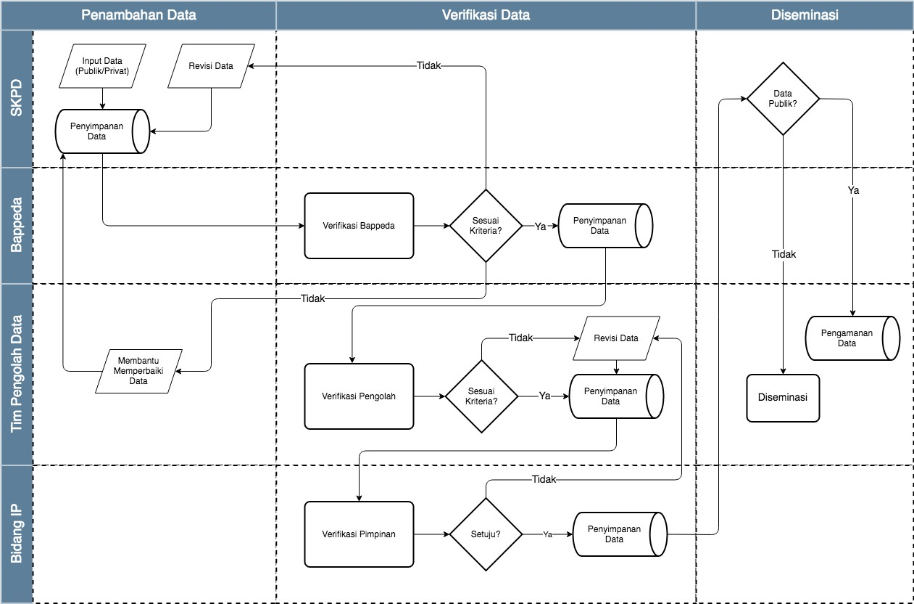
Gambar 1 Flowchart sistem Open Data Jakarta v2.0

Pada Gambar 1, dapat dilihat bahwa terdapat 4 subjek yaitu SKPD (data owner), Bappeda (data checker), Tim Pengolah Data (data preprocessor), Bidang IP (data verifikator), yang masing-masing fungsi sebagaimana masuk ke dalam sumber daya non-teknis yang telah diuraikan pada sesi 4.2.2.

6.2 Use Case diagram

Berdasarkan kebutuhan organisasi, sistem Open Data Jakarta memiliki 6 kategori pengguna sebagaimana telah diuraikan pada sesi 4.2.2. Use Case diagram dapat mendeskripsikan sebuah interaksi antara satu atau lebih aktor dengan sistem yang akan dibuat. Use case diagram juga dapat digunakan untuk mengetahui fungsi apa saja yang ada di dalam sebuah sistem dan dapat juga mempresentasikan sebuah interaksi aktor dengan sistem.
Dengan spesifikasi flowchart yang diinginkan, fungsi-fungsi manajemen yang dapat dilakukan oleh masing-masing kategori pengguna (aktor) digambarkan dengan diagram kasus penggunaan (use case diagram) pada Gambar 2.

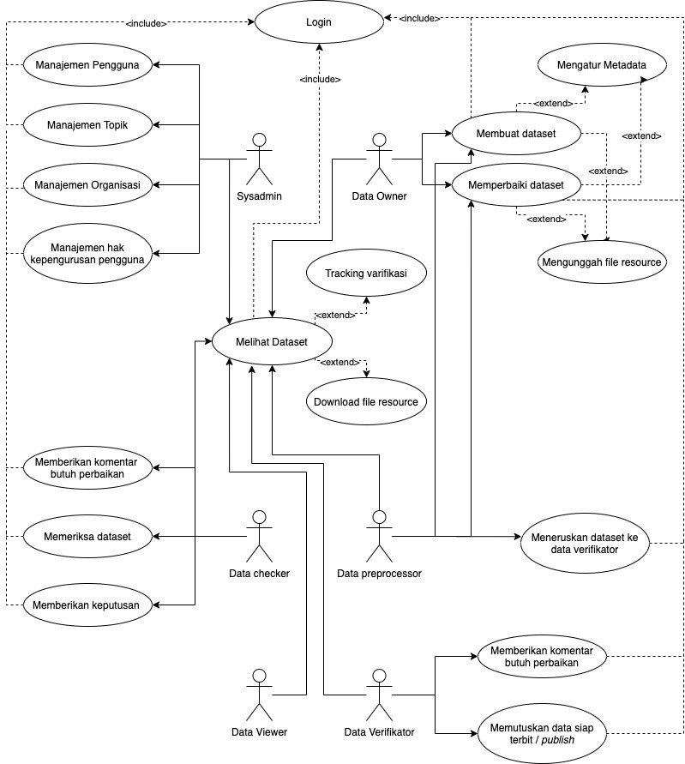
Gambar 2 Use case diagram Open Data Jakarta v2.0

Pada gambar 3 dapat dilihat beberapa usecase inti yang ditandai dengan lingkar berwarna jingga. Setiap koneksi garis putus berwarna hitam adalah mode extend yang dapat dilakukan oleh case inti. Sedangkan garis putus berwarna jingga adalah extension atau merupakan hubungan yang dapat dilakukan dari usecase inti.

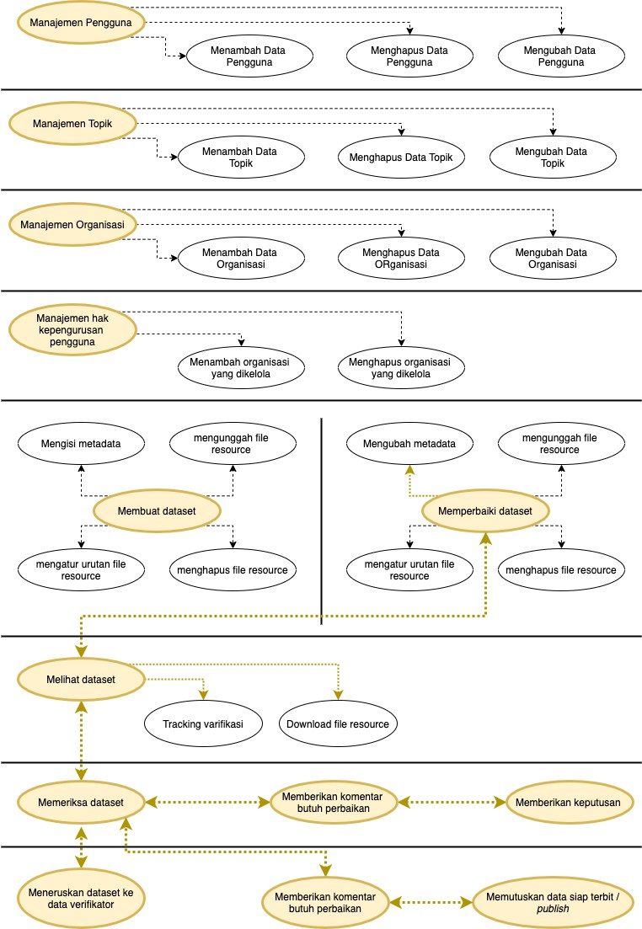

Gambar 3 Point extend usecase Open data Jakarta v2.0

6.3 Database

Selain pertimbangan rancangan sistem dan kebutuhan organisasi, database Open Data Jakarta v2.0 juga menyesuaikan dari sistem sebelumnya yang menggunakan platform CKAN. Oleh karena itu, database dirancang sedemikian rupa agar data pada database CKAN dapat ditransfer/migrasi ke dalam database Open Data Jakarta v2.0. Adapun arsitektur database dapat dilihat pada Gambar 4.

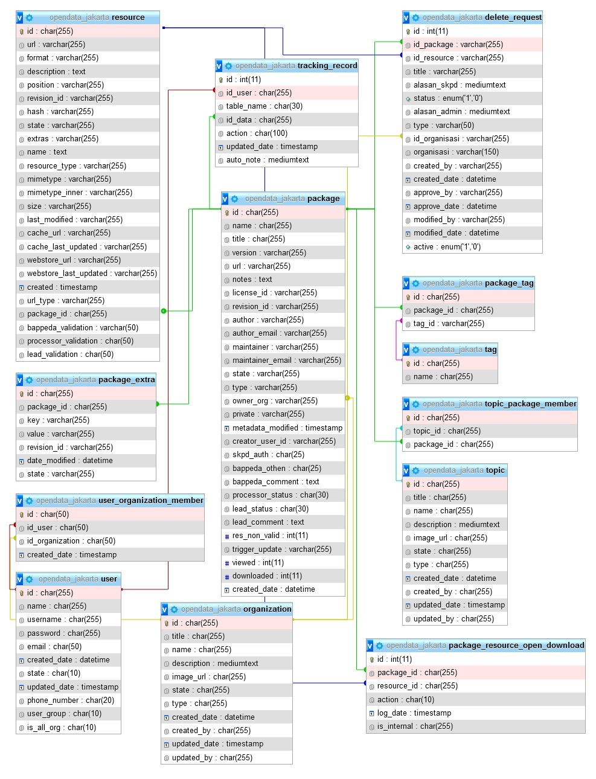
Gambar 4 Arsitektur desain basis data Open Data Jakarta v2.0

6.4 Migrasi Data

Migrasi data dilakukan untuk memindahkan data Open Data Jakarta v.1.0 yang ada pada platform CKAN ke dalam konsep dan struktur database yang baru. Terdapat dua hal utama yang dilakukan yaitu proses “restrukturisasi database” dan “pemindahan file berkas”. Untuk memenuhi kebutuhan tersebut, pengembang menggunakan bahasa pemrograman python sederhana agar dapat dengan mudah dibaca dan di implementasi. Adapun kode program untuk restrukturisasi database dan pemindahan file berkas dapat dilihat pada Lampiran 1 dan Lampiran 2. Proses migrasi data dilakukan dengan memberikan output yang dapat diimport ke dalam tabel-tabel pada Gambar 4. Keterangan lebih lengkap mengenai tabel-tabel pada Gambar 4 dapat dilihat pada Tabel 2.

Tabel 2 Kumpulan tabel dalam database sistem Open Data Jakarta v2.0

Nama tabel Keterangan

Delete request Daftar permintaan hapus dataset atau berkas file dari pengguna skpd kepada tim pengolah data diskominfotik, yang bertujuan agar dataset atau resource tidak langsung hilang dari sistem tetapi ada pengecekan terlebih dahulu bahwa dataset atau berkas file tersebut memang layak untuk dihapus.

Organization Daftar organisasi yang dimiliki sistem. Seluruh dataset harus memiliki minimal dan maksimal satu organisasi.

Package Daftar dataset yang berstatus aktif atau sudah dihapus. Juga digunakan untuk melihat status proses verifikasi.

Package extra Tambahan metadata yang dimiliki oleh
dataset atau bersifat foreign key.

Package resource open download Pencatatan dataset dan file resource yang dilihat atau diunduh oleh pengguna tanpa login maupun pengguna yang sudah login.

Package tag Penghubung antara tabel package dengan
tabel tag dengan konsep many to many

Resource Daftar berkas file yang statusnya aktif atau sudah dihapus dan selalu memiliki hubungan dengan tabel package

Tag Daftar tag yang ada pada sistem, juga sebagai
pengkategorian dataset berdasarkan tag. Topic Daftar topik yang ada pada sistem, juga

sebagai pengkategorian dataset berdasarkan
topik.

Topic package member Penghubung antara tabel package dengan
tabel topic dengan konsep many to many

Tracking record Pencatatan semua transaksi atau aktivitas yang dilakukan oleh pengguna seperti login, tambah, ubah, hapus dataset atau berkas file.

user Daftar pengguna yang memiliki akses masuk
atau login ke dalam sistem.

User organization member Penghubung antara tabel user dengan tabel
organization dengan konsep many to many

6.5 Arsitektur Framework

Open Data Jakarta dibangun dengan menggunakan framework PHP yaitu menggunakan framework “CodeIgniter v3”. Codeigniter adalah suatu framework dengan konsep MVC. Model-View-Controller atau MVC adalah sebuah metode untuk membuat sebuah aplikasi dengan memisahkan data dari tampilan dan cara bagaimana memprosesnya. Dalam implementasinya kebanyakan kerangka kerja dalam aplikasi web adalah berbasis arsitektur MVC.
1. Model, Model mewakili struktur data. Model merupakan bagian yang bertugas untuk mengatur, menyiapkan, memanipulasi, dan mengorganisir data (biasanya dari basis data). Tugas yang ia lakukan meliputi memasukkan data ke basis data, pembaruan data, menghapus data, dan lain-lain. Model menjalankan tugasnya berdasarkan instruksi dari controller.
2. View, View merupakan bagian yang mengatur tampilan ke pengguna. Bisa
dikatakan berupa halaman web.
3. Controller, Controller merupakan bagian yang menjembatani model dan view. Controller berisi perintah-perintah yang berfungsi untuk memproses suatu data dan mengirimkannya ke halaman web.

Dengan menggunakan metode MVC maka aplikasi akan lebih mudah untuk dirawat dan dikembangkan. Untuk memahami metode pengembangan aplikasi menggunakan MVC diperlukan pengetahuan tentang pemrograman berorientasi objek (Object-oriented programming). Adapun struktur kode program pada framework yang menggunakan MVC ini dapat dilihat pada Gambar 5.

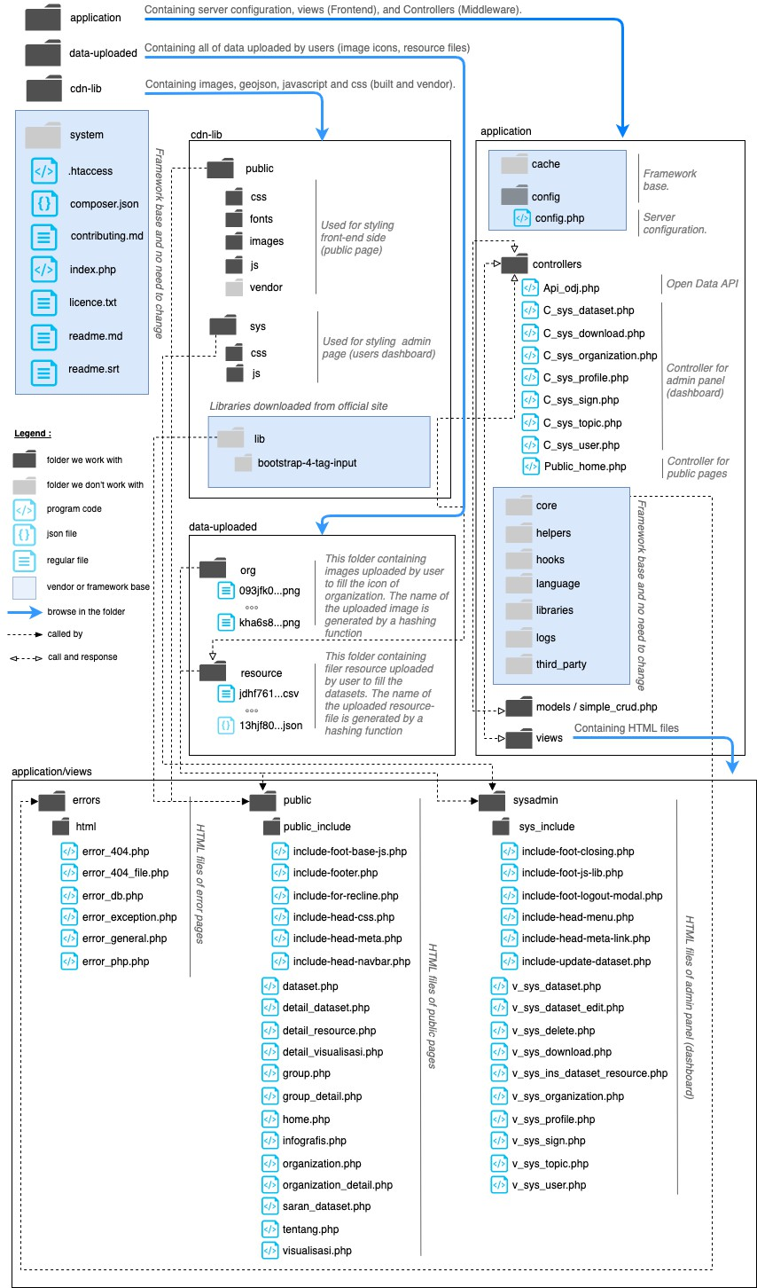

Gambar 5 Arsitektur framework Open Data Jakarta v2.0

7. BACK-END CLASS & FUNCTIONS

Sesi ini memberikan informasi terkait keseluruhan class dan function yang terdapat pada sistem Open Data Jakarta. Saat ini, sistem Open Data Jakarta memiliki sembilan class yang terdiri dari delapan class difokuskan untuk pengguna dalam pengolahan data dan manajemen sistem, serta satu class yang difokuskan untuk tampilan penggunan non login (masyarakat publik).

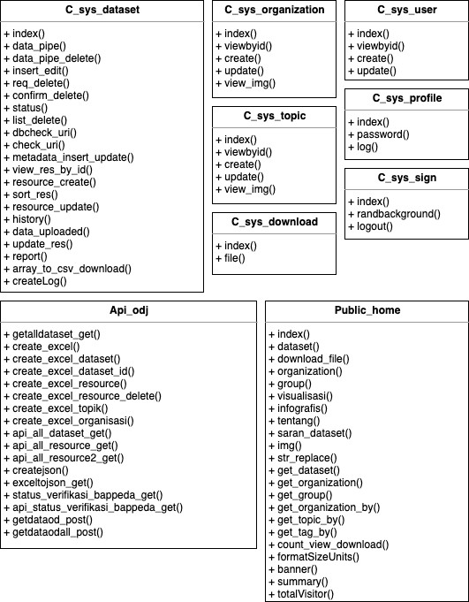

Gambar 6 Daftar Class pada sistem Open Data Jakarta v2.0

7.1 application/controller/C_sys_dataset

Class yang memiliki berbagai fungsi dikhususkan untuk melakukan manajemen pada dataset. Class ini digunakan oleh keseluruhan pengguna yang memiliki akses login ke dalam sistem. Namun, beberapa fungsi dibuat khusus untuk pengguna dengan hak akses tertentu.
Class ini merupakan class inti dari pada sistem Open Data Jakarta. Banyak
terdapat pengolahan data dan koneksi berbagai tabel database dalam menyajikan dataset dan pengelolaan dataset. Apabila dimasa depan terdapat perubahan mekanisme pengelolaan open data terutama manajemen dataset, maka Class C_sys_dataset inilah yang akan banyak mengalami perubahan. Sedikit kesalahan pada kode program di class ini akan mengakibatkan kerusakan serius pada sistem Open Data Jakarta.

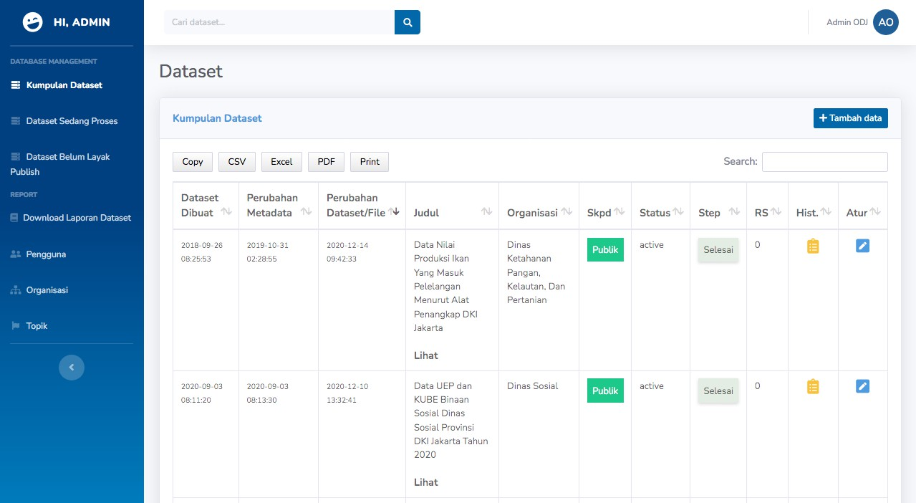
Gambar 7 Sys dataset view

Tabel 3 Fungsi-fungsi pada C_sys_dataset

Nama Fungsi

index() Fungsi index untuk menampilkan kumpulan dataset pada laman https://data.jakarta.go.id/sys/data. Tujuan fungsi tersebut adalah mengambil data dari database, memilih beberapa tabel, lalu melakukan pemrosesan untuk menggabungkan kolom-kolom yang akan digunakan. Pada hak akses SKPD, data digabungkan (join) dengan tabel user untuk memastikan data tersebut memang dimiliki oleh pengguna yang bersangkutan. Pada hak akses Pengolah, data yang masuk hanyalah data-data SKPD yang sudah ditugaskan untuk dipantau (PIC).

data_pipe() Fungsi ini bertujuan untuk menarik daftar dataset dengan menggunakan fungsi ajax https://data.jakarta.go.id/sys/data/pipe pada dashboard pengguna yang telah login. Tujuannya untuk mempercepat proses load data seperti filter dan pagination.

data_pipe_delete() Fungsi ini bertujuan untuk menampilkan daftar permintaan hapus dataset dari SKPD ke tim pengolah data Diskominfotik dengan menggunakan fungsi ajax
https://data.jakarta.go.id/sys/data/pipe_delete.

insert_edit() Fungsi ini bertujuan untuk masuk ke dalam form ubah dataset atau berkas file. Pada form tersebut mengambil data berkas file disesuaikan dengan file yang masuk ke dalam dataset terkait.

req_delete() Fungsi ini bertujuan melakukan request atau permintaan untuk menghapus dataset atau berkas file dari SKPD kepada tim pengolah data Diskominfotik.

confirm_delete() Fungsi ini bertujuan untuk menerima atau menolak permintaan hapus dari SKPD. Jika permintaan hapus disetujui, maka status dataset atau berkas file diperbaharui menjadi "hapus". Jika permintaan ditolak, maka status dataset atau berkas file tidak akan berubah.

status() Fungsi ini bertujuan untuk melakukan unpublish dataset yang sudah publish. jika suatu kondisi mengharuskan salah satu dataset tidak boleh diakses, maka user verifikator atau pimpinan harus menjalankan fungsi tersebut (fungsi hanya terdapat pada pengguna verifikator atau pimpinan).

list_delete() Fungsi https://data.jakarta.go.id/sys/data/list_delete ini bertujuan untuk menampilkan permintaan hapus dataset atau berkas file dari SKPD ke tim pengolah data Diskominfotik.

dbcheck_uri() Fungsi ini bersifat privat dan bertujuan untuk melakukan pengecekan nama URL dataset. jika URL sudah terpakai maka sistem akan memunculkan informasi/saran untuk mengganti judul dataset. Harapannya, seluruh URL dapat disimpan tanpa duplikasi.

check_uri() Bertujuan untuk memanggil fungsi dbcheck_uri().

metadata_insert_up date()
Fungsi ini bertujuan untuk membuat dataset atau
mengubah metadata dataset dengan ketentuan yang

berbeda pada masing-masing hak akses. Ketika user SKPD melakukan update, secara otomatis status dataset akan berubah menjadi "draft" dan harus melalui proses verifikasi mulai dari "belum diperiksa bappeda".

view_res_by_id() Fungsi ini bertujuan untuk melihat detail dari berkas file yang nantinya dapat diunduh dari panel admin. File berkas dapat diunduh walaupun statusnya masih dalam proses verifikasi.

resource_create() Fungsi ini bertujuan untuk mengunggah/mengunduh berkas file baru dalam dataset. Setiap file baru yang diunggah akan melewati tahapan verifikasi.

sort_res() Fungsi ini bertujuan untuk melakukan perubahan posisi (sorting) pada file berkas dalam suatu dataset.

resource_update() Fungsi ini bertujuan untuk merlakukan perubahan pada berkas file yang sudah ada dalam dataset. Setiap file baru yang diunggah akan melewati proses verifikasi.

history() Fungsi ini bertujuan untuk melihat catatan perubahan
yang dilakukan pada suatu dataset dan/atau berkas file.

data_uploaded() Fungsi ini bertujuan untuk mengunggah berkas file ke
dalam suatu dataset.

update_res() Fungsi ini bertujuan untuk menghitung file yang harus
diperiksa pada saat melakukan verifikasi.

report() Fungsi ini bertujuan untuk menampilkan rekap data khususnya rekap penambahan dataset dan penambahan berkas file. Fungsi ini juga dapat melakukan export rekap
data ke dalam sebuah file csv.

array_to_csv_downl oad()
Fungsi ini bertujuan untuk mengkonversi data array
menjadi file csv dan dapat digunakan dimana saja dalam
satu class.

createLog() Fungsi ini bersifat privat dan bertujuan untuk membuat log berisi data-data penambahan atau perubahan dataset yang berbentuk file.

7.2 application/controller/C_sys_download

Class yang memiliki fungsi untuk menampilkan dan mengunduh daftar
dokumen laporan dari hasil penarikan data yang dilakukan oleh controller api_odj.

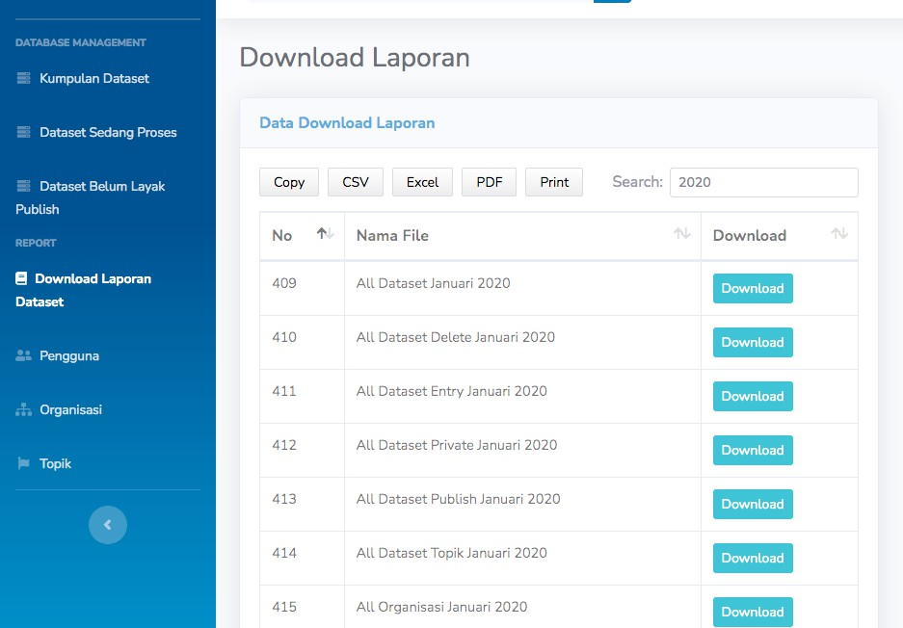

Gambar 8 Sys download view

Tabel 4 Fungsi-fungsi pada C_sys_download

Nama Fungsi

index() Fungsi ini bertujuan untuk menampilkan laporan perbulan, seperti; dataset yang berstatus active atau deleted, dataset yang dihapus, dataset yang ditambah, dataset yang berstatus publish, dataset yang berstatus private, data file berkas, dan
lain-lain pada rentang waktu tertentu.

file() Fungsi ini bertujuan sebagai fungsi untuk mengunduh file
laporan.

7.3 application/controller/c_sys_organization

Class yang memiliki fungsi untuk melakukan manajemen data organisasi dan
melihat gambar icon organisasi yang akan tampil di halaman website.

Tabel 5 Fungsi-fungsi pada C_sys_organization

Nama Fungsi

index() Fungsi ini bertujuan untuk melihat daftar organisasi beserta
dataset yang sudah diinput.

viewbyid() Fungsi ini bertujuan untuk meilhat detail dari organisasi
yang dipilih.

create() Fungsi ini bertujuan untuk menambahkan data organisasi (skpd).

update() Fungsi ini bertujuan untuk mengubah data organisasi (skpd)
yang sudah dibuat.

view_img() Fungsi ini bertujuan untuk melihat gambar organisasi yang
sudah diinputkan sebelumnya.

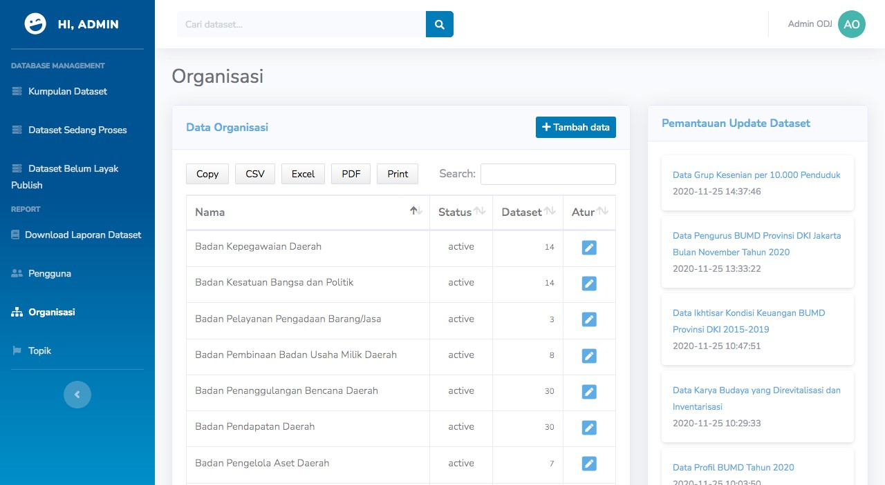
Gambar 9 Sys organization view

7.4 application/controller/c_sys_profile

Class yang memiliki fungsi untuk mengubah data pribadi seperti nama, no
telepon, email, dan password.

Tabel 6 Fungsi-fungsi pada C_sys_profile

Nama Fungsi

index() Fungsi ini bertujuan untuk masuk kedalam form ubah
profile pengguna seperti nama, no telepon, dan email.

password() Fungsi ini bertujuan untuk masuk ke dalam form ubah password. Sebelum berhasil mengubah password, pengguna harus menginputkan password sebelumnya untuk memastikan bahwa pengguna tersebut adalah pemilik akun sebenarnya.

log() Fungsi ini bertujuan untuk mencatat perubahan-perubahan yang dilakukan pengguna ketika mengubah data pada form ubah profile pengguna.

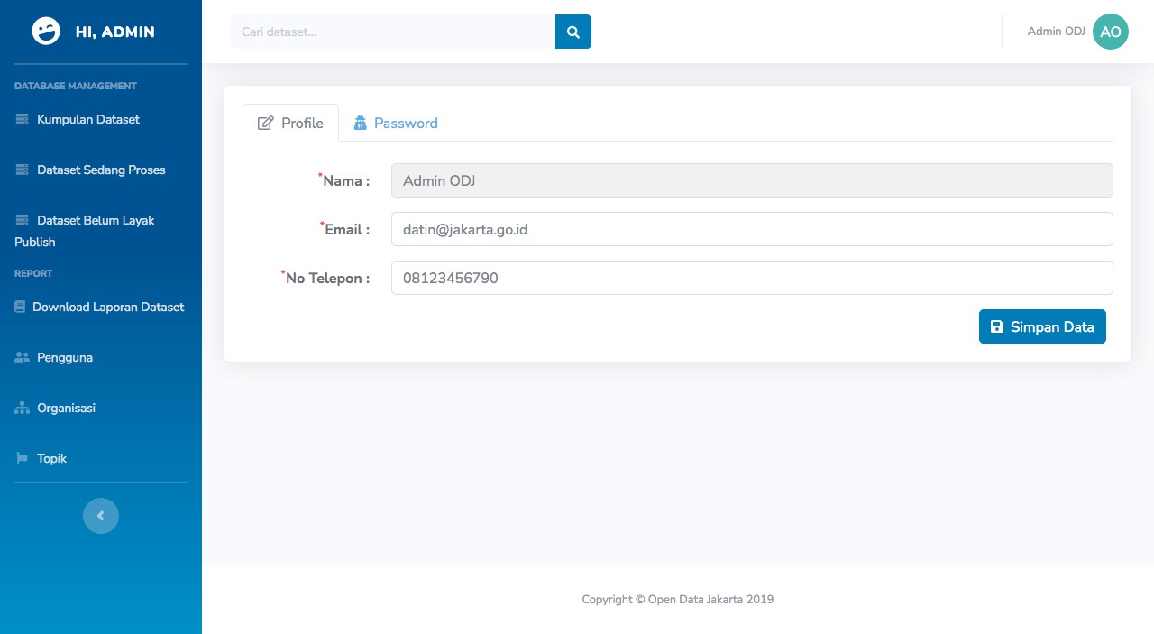
Gambar 10 Sys profile view

7.5 application/controller/c_sys_sign

Class yang memiliki fungsi untuk menangani form login user dengan membentuk session jika username dan password sesuai atau terdaftar. Pada class ini terdapat juga fungsi untuk mengakhiri session.

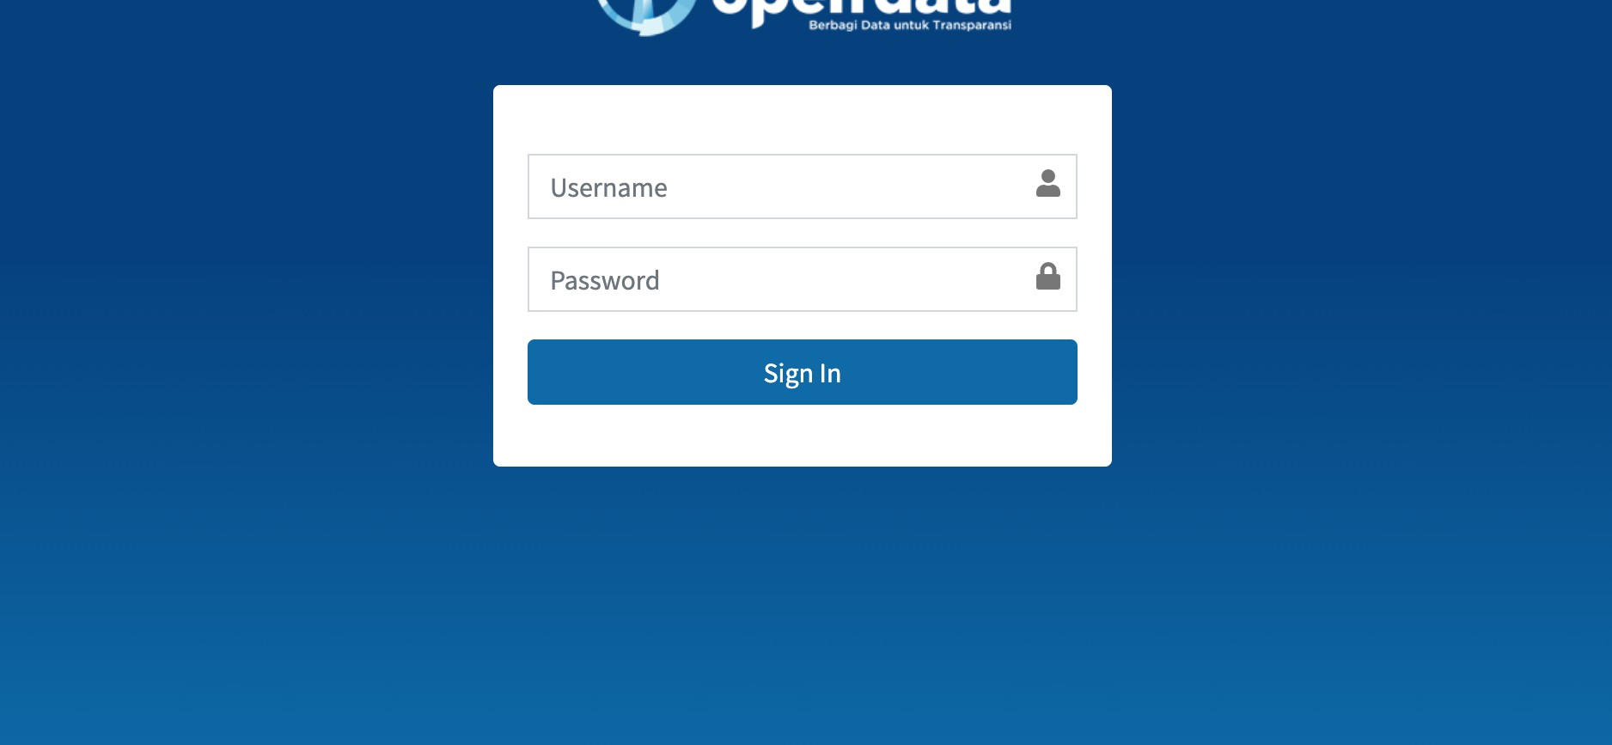
Gambar 11 Sys sign view

Tabel 7 Fungsi-fungsi pada C_sys_sign

Nama Fungsi

index() Fungsi ini bertujuan sebagai form login. Jika session pengguna belum ada, maka akan diarahkan untuk memasukkan username dan password. Jika pada browser sudah terdapat session Open Data Jakarta, maka akan diarahkan ke dalam daftar kumpulan dataset. Semua perilaku berhasil login maupun tidak berhasil login, akan dicatat dalam tabel tracking record, hal ini bertujuan untuk memonitor seberapa sering form tersebut digunakan untuk
perlakuan positif maupun negatif.

randBackground() Fungsi ini untuk mendapatkan warna background untuk
pengguna di halaman CMS opendata.

logout() Fungsi ini bertujuan untuk menghapus session atau keluar
dari sistem.

7.6 application/controller/c_sys_topic

Class yang memiliki fungsi untuk melakukan manajemen data topik dan
melihat gambar topik yang nantinya akan tampil di halaman website.

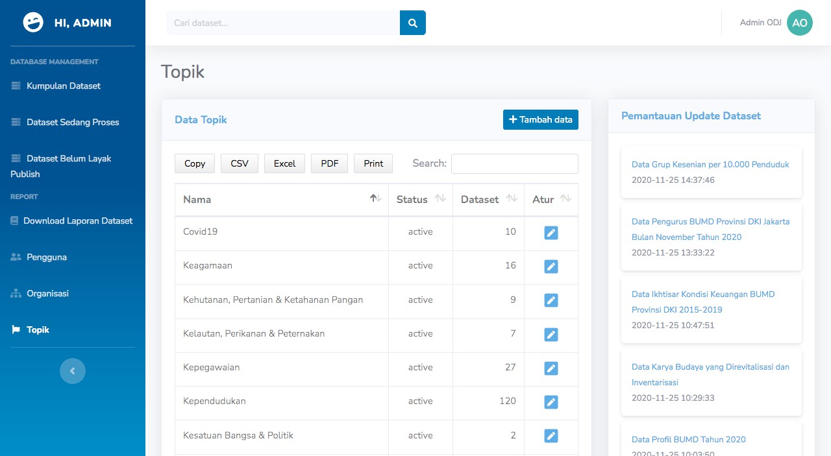
Gambar 12 Sys topic view

Tabel 8 Fungsi-fungsi pada C_sys_topic

Nama Fungsi

index() Fungsi ini bertujuan untuk melihat daftar topik yang ada di dalam sistem beserta jumlah dataset yang terhubung dengan topik tersebut.

viewbyid() Fungsi ini bertujuan untuk melihat detail informasi dari
satu topik yang sudah dipilih.

create() Fungsi ini bertujuan untuk membuat topik baru dengan menginputkan nama topik, deskripsi topik, dan mengunggah gambar icon topik.

update() Fungsi ini bertujuan untuk mengubah inisiasi topik yang
sudah diinputkan.

view_img() Fungsi ini bertujuan untuk melihat gambar topik yang telah
diinputkan sebelumnya.

7.7 application/controller/c_sys_user

Class yang memiliki fungsi untuk melakukan manajemen data user dan
mengatur hak akses pada user tersebut.

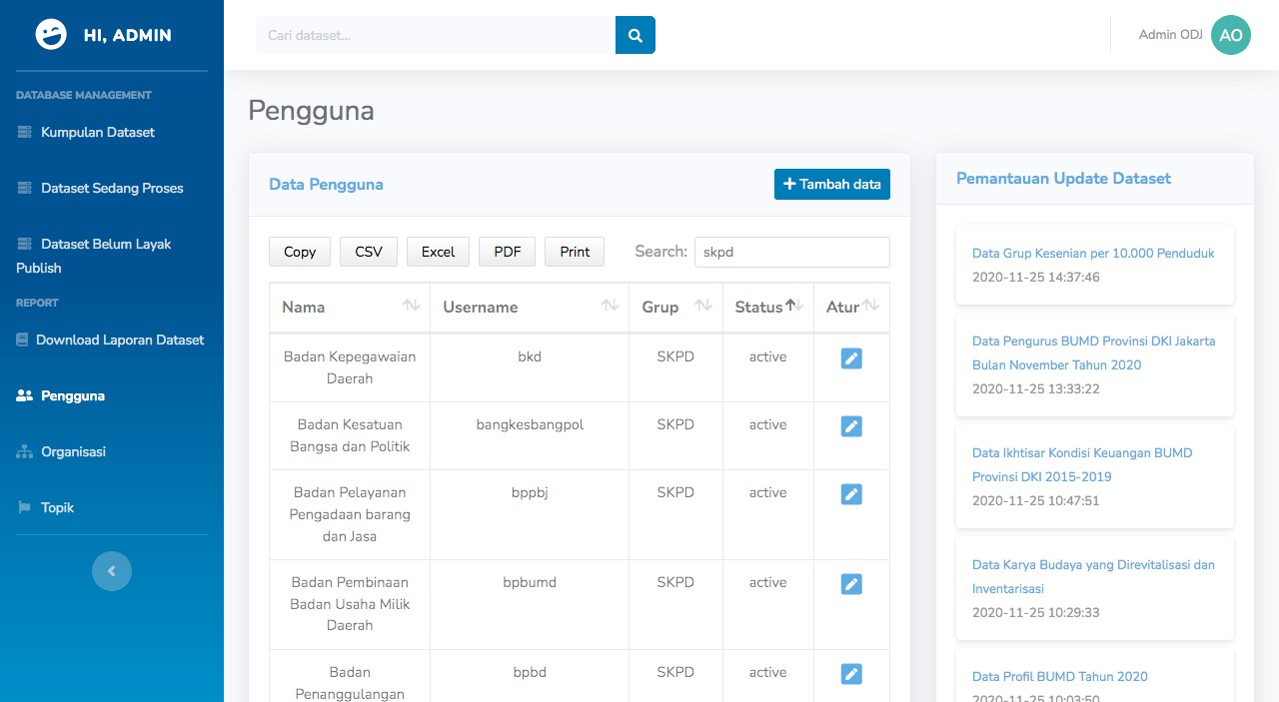

Gambar 13 Sys user view

Tabel 9 Fungsi-fungsi pada C_sys_user

Nama Fungsi

index() Fungsi ini bertujuan untuk melihat daftar user aktif beserta
hak aksesnya yang ada pada sistem.

viewbyid() Fungsi ini bertujuan untuk mendapatkan daftar organisasi yang dikelola atau (PIC) oleh user tersebut. Pada dasarnya, Setiap pengolah data menjadi PIC di beberapa SKPD.

create() Fungsi ini bertujuan untuk membuat user baru dengan hak akses tertentu. Fungsi ini juga melkaukan pengecekan duplikasi username.

update() Fungsi ini bertujuan untuk mengubah informasi user seperti nama, username, email, no telepon, dan lain-lain. Sistem akan melakukan pengecekan duplikasi username kembali ketika selesai memperbaharui suatu data user.

7.8 application/controller/api_odj

Class ini memiliki fungsi untuk menyediakan API sebagai salah satu jembatan komunikasi antar sistem untuk digunakan pada sistem internal atau eksternal sesuai kebutuhan.

Tabel 10 Fungsi-fungsi pada api_odj

Nama Fungsi

getalldataset_get() Fungsi ini bertujuan untuk membuat report berupa file excel seperti dataset yang diinput, dihapus, dataset yang memiliki topik, dan lain-lain yang dijalankan secara otomatis dan terjadwal menggunakan cronjob di CPU file sharing 192.168.90.2.

create_excel() Fungsi ini bersifat private dan bertujuan untuk memanggil library excel pihak ketiga untuk mengubah data-data yang diinginkan menjadi excel file.

create_excel_dataset() Fungsi ini bersifat private dan memiliki tujuan yang sama dengan fungsi create_excel(), namun, fungsi ini lebih fokus untuk kebutuhan file dataset.

create_excel_dataset_id() (fungsi ini tidak digunakan dan hanya untuk kebutuhan
testing)

create_excel_resource() Fungsi ini bersifat private dan memiliki tujuan yang sama dengan fungsi create_excel(), namun, fungsi ini lebih fokus untuk kebutuhan file resource.

create_excel_resource_del ete()
Fungsi ini bersifat private dan memiliki tujuan yang sama dengan fungsi create_excel_resource(), namun, fungsi ini lebih fokus untuk kebutuhan file resource yang sudah dihapus.

create_excel_topik() Fungsi ini bersifat private dan memiliki tujuan yang sama dengan fungsi create_excel(), namun, fungsi ini lebih fokus untuk kebutuhan file dataset beserta topiknya.

create_excel_organisasi() Fungsi ini bersifat private dan memiliki tujuan yang sama dengan fungsi create_excel(), namun, fungsi ini lebih fokus pada daftar organisasi beserta tanggal dibuatnya.

api_all_dataset_get() Fungsi ini bertujuan menyediakan JSON semua
dataset dari hasil penarikan data di sistem untuk

kebutuhan sistem JODA yang bisa di akses di
192.168.90.2/joda

api_all_resource_get() Fungsi ini bertujuan menyediakan JSON semua resource dari hasil penarikan data di sistem untuk kebutuhan sistem JODA yang bisa di akses di
192.168.90.2/joda

api_all_resource2_get() Fungsi ini memiliki tujuan yang sama dengan api_all_resource_get(), yang membedakan hanya keluaran data dari hasil query.

createJson() Fungsi ini bersifat private yang bertujuan untuk mengkonversi data-data hasil query dibuat menjadi file json.

exceltojson_get() Fungsi ini bertujuan untuk melakukan konversi dari
file excel yang menjadi json.

status_verifikasi_bappeda
_get()
Fungsi ini bertujuan untuk membuat file json dari
hasil query semua status bappeda pada dataset yang
sedang dalam proses verifikasi.

api_status_verifikasi_bapp eda_get()
Fungsi ini bertujuan untuk mengambil file json dari hasil fungsi status_verifikasi_bappeda_get(). Selain itu, manfaat langsung mengakses file json ialah load akses data akan lebih cepat karena tidak membutuhkan query dan mengurangi beban server. Fungsi ini juga digunakan untuk penarikan dari sistem JODA
192.168.90.2/joda

getdataod_post() Fungsi ini bertujuan untuk mengirimkan daftar dataset yang statusnya publish ke sistem PPID, yang nantinya akan masuk dalam daftar informasi publik PPID.

getdataodall_post() Fungsi ini bertujuan untuk mengirimkan daftar dataset yang statusnya publish dan private ke sistem PPID, yang digunakan untuk memastikan data-data
sesuai dengan status pada open data.

7.9 application/controller/public_home

Class yang memiliki fungsi untuk menangani semua halaman frontend beserta pengamanan pada fungsi pencarian data untuk ditampilkan kepada visitor yang mengunjungi portal data jakarta seperti halaman beranda, dataset, organisasi, topik, infografis, visualisasi, tentang, dan saran dataset.

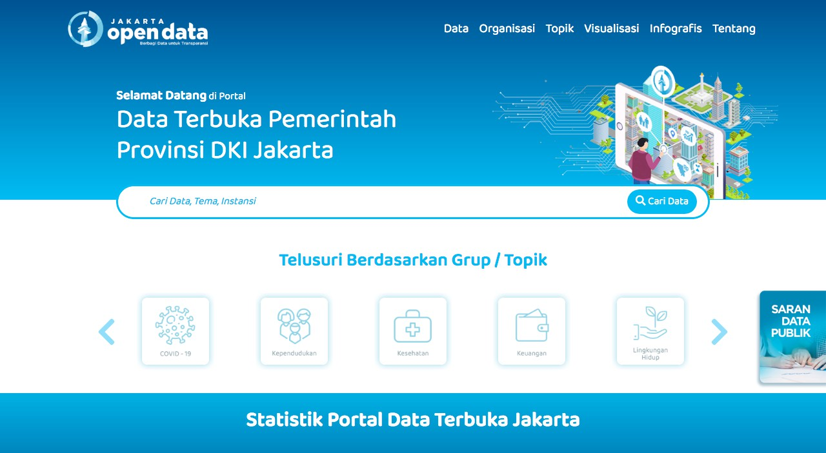

Gambar 14 Public home view

Tabel 11 Fungsi-fungsi pada public_home

Nama Fungsi

index() Fungsi ini bertujuan untuk menampilkan halaman beranda (home) dari website Portal Open Data Jakarta. Di dalam fungsi ini terdapat beberapa penarikan data seperti laporan jumlah dataset, jumlah berkas file, jumlah organisasi, jumlah topik, daftar topik, daftar dataset terbaru, dan daftar visualisasi terbaru. Link
akses https://data.jakarta.go.id/

dataset() Fungsi ini bertujuan untuk menangani halaman yang berhubungan dengan dataset, seperti daftar dataset secara keseluruhan, halaman detail dataset beserta berkas file yang sudah selesai verifikasi dan bersifat publish, dan halaman detail berkas file. Link akses
https://data.jakarta.go.id/dataset

download_file() Fungsi ini bertujuan untuk mendownload file-file yang
sudah selesai verifikasi, jika dataset bersifat publik

maka, berkas file bisa diunduh oleh siapapun, tetapi jika dataset bersifat privat maka hanya user yang sudah berhasil login yang dapat mengunduh dataset tersebut. Salah satu link contoh untuk download file https://data.jakarta.go.id/dataset/f6563545-a363-
492d-ba66-bcdc2823a6bc/resource/babbf7be-7563-
44da-a3d2-fd8db229d5fa/download/Data-Retribusi- Daerah-Dinas-Koperasi-UKM-serta-Perdagangan- Prov-DKI-Jakarta-Bulan-Juli-2020.csv

organization() Fungsi ini bertujuan untuk menampilkan data-data organisasi dan rincian dari organisasi tersebut seperti deskripsi organisasi dan dataset-dataset yang dimiliki oleh organisasi tersebut. Link akses
https://data.jakarta.go.id/organization

group() Fungsi bertujuan untuk menampilkan data-data topik dan rincian dari topik seperti dataset-dataset yang termasuk ke dalam topik tersebut. Link akses
https://data.jakarta.go.id/group

visualisasi() Fungsi ini bertujuan untuk menampilkan daftar dan detail visualisasi yang dimiliki oleh Pemerintah Provinsi DKI Jakarta, yang diinput melalui sistem dashboard. Link akses
https://data.jakarta.go.id/visualisasi

Infografis() Fungsi ini bertujuan untuk menampilkan daftar infografis yang dimiliki oleh Pemerintah Provinsi DKI Jakarta, yang diinput melalui sistem dashboard. Link akses
https://data.jakarta.go.id/infografis

tentang() Fungsi ini bertujuan untuk menampilkan deskripsi
singkat mengenai Portal Jakarta Open Data. Link akses
https://data.jakarta.go.id/tentang

saran_dataset() Fungsi ini bertujuan untuk menampung saran-saran dari pengunjung Portal Open Data Jakarta yang nantinya, data-data saran tersebut dapat diakses melalui sistem dashboard. Link akses
https://data.jakarta.go.id/saran-dataset

img() Fungsi ini bertujuan untuk menampilkan gambar
organisasi atau topik yang diinput oleh admin dan

menyembunyikan path dari gambar tersebut. Link akses https://data.jakarta.go.id/view/organization/a34d5b
1691d5691caa7d5708fe53c061.jpg,
https://data.jakarta.go.id/view/group/6bddfa0dfe55
9a2a9a225a424a3d28bd.png

str_replace() Fungsi ini bersifat privat dan bertujuan untuk mengganti karakter yang sudah ditentukan sebagai salah satu cara pencegahan upaya percobaan pengambilan file yang tidak bersifat publik.

get_dataset() Fungsi ini bersifat privat dan dapat digunakan dimanapun yang bertujuan untuk meminimalisasi pembuatan fungsi yang tujuannya sama. Fungsi ini digunakan untuk menampilkan daftar dataset yang bisa digabungkan dengan filter by tag, organisasi, topik, dataset bersifat publik atau privat dan bisa diurutkan berdasarkan judul, dan tanggal publish.

get_organization() Fungsi ini bersifat privat dan dapat digunakan dimanapun yang bertujuan untuk meminimalisasi pembuatan fungsi yang tujuannya sama. Fungsi ini digunakan untuk menampilkan daftar organisasi yang bisa digabungkan dengan mengurutkan daftar berdasarkan judul.

get_group() Fungsi ini bersifat privat dan dapat digunakan dimanapun yang bertujuan untuk meminimalisasi pembuatan fungsi yang tujuannya sama. Fungsi ini digunakan untuk menampilkan daftar topik yang bisa digabungkan dengan mengurutkan daftar berdasarkan judul.

get_organization_by() Fungsi ini bersifat privat dan dapat digunakan dimanapun yang bertujuan untuk meminimalisasi pembuatan fungsi yang tujuannya sama. Fungsi ini digunakan untuk menampilkan hanya satu data organisasi atau mengambil detail organisasi seperti nama organisasi, deskripsi, gambar organisasi.

get_topic_by() Fungsi ini bersifat privat dan dapat digunakan dimanapun yang bertujuan untuk meminimalisasi pembuatan fungsi yang tujuannya sama. Fungsi ini digunakan untuk menampilkan hanya satu data topik

atau mengambil detail topik seperti nama, deskripsi,
gambar topik.

get_tag_by() Fungsi ini bersifat privat dan dapat digunakan dimanapun yang bertujuan untuk meminimalisasi pembuatan fungsi yang tujuannya sama. Fungsi ini digunakan untuk menampilkan semua tag yang ada pada dataset tersebut ketika user masuk ke halaman detail dataset.

count_view_download() Fungsi ini bersifat privat yang bertujuan untuk menghitung jumlah view pada dataset dan berkas file yang dilakukan oleh pengguna logged-in maupun tidak (publik).

formatSizeUnits() Fungsi ini bersifat private dan bertujuan untuk menghitung jumlah ukuran file. fungsi ini bertujuan memberikan informasi besaran file resource kepada pengguna sebelum memutuskan untuk mengunduh file tersebut.

banner() Fungsi ini bertujuan untuk mengambil gambar banner yang ada pada sistem dashboard yang nantinya akan tampil di halaman beranda Portal Open Data.

summary() Fungsi ini bertujuan untuk mengurangi beban dari akses halaman beranda. Fungsi ini dipanggil dengan menggunakan jquery ajax yang dijalankan menunggu ketika halaman beranda selesai di load.

totalVisitor() Fungsi ini bertujuan untuk mengambil jumlah visitor yang mengakses website open data yang dicatat oleh sistem analisa yang bernama piwik.

8. FRONT-END FILES

Seluruh HTML file berada pada folder application/views. Terdapat tiga folder utama pada views yaitu; errors, public, dan sysadmin. Folder errors adalah folder yang menyimpan HTML file yang memberikan halaman pesan error sesuai dengan masing- masing kategori error. Folder public adalah folder yang menyimpan HTML file yang berfokus pada tampilan publik ataupun tampilan yang akan dilihat dan digunakan oleh masyarakat publik. Folder sysadmin adalah folder yang menyimpan HTML file yang membentuk tampilan dashboard ataupun admin panel dimana seluruh tenaga non-teknis bekerja didalamnya.

Pada folder public dan sysadmin terdapat folder include yang berisi reusable HTML yang selalu dipanggil pada halaman-halaman yang tersedia. File-file html tersebut biasanya membentuk hal-hal yang reusable seperti header dan footer pada halaman website.

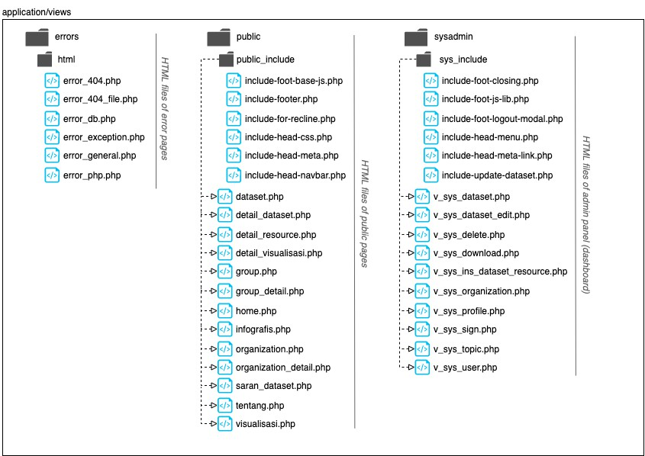
Gambar 15 Struktur HMTL pada front-end view

9. ROUTING LINK TO FUNCTION

Open Data Jakarta menggunakan routing untuk mengatur koneksi antara URL
dengan controller. Berikut daftar URL dan routing controller;

Tabel 12 Routing link to function Open Data Jakarta v2.0

Route | controller
$route["default_controller"] | public_home
$route["public_home/download_file"] | c_alert/page_not_found
$route["dataset/(:any)/resource/(:any)/down
load/(:any)"] | public_home/download_file
$route["dataset/(:any)/resource/(:any)"] | public_home/dataset/$1/resource/$2
$route["dataset/(:any)"] | public_home/dataset/$1
$route["organization/(:any)"] | public_home/organization/$1
$route["group/(:any)"] | public_home/group/$1

$route["saran-dataset"] | public_home/saran_dataset
$route["visualisasi/img/(:num)"] | public_home/visualisasi/img/$1
$route["visualisasi/detail/(:num)"] | public_home/visualisasi/detail/$1
$route["infografis/img/(:num)"] | public_home/infografis/img/$1
$route["infografis/detail/(:num)"] | public_home/infografis/detail/$1
$route["banner/file/(:any)"] | public_home/banner2/$1
$route["banner/(:any)"] | public_home/banner/$1
$route["data-download/resource/(:any)"] | c_sys_dataset/data_uploaded/$1
$route["data-download2/resource/(:any)"] | c_sys_dataset/data_uploaded2/$1
$route["login"] | c_sys_sign
$route["view/([a-z]+)/(:any)"] | public_home/img/$1/$2
$route["([a-z]+)"] | public_home/$1
$route["404_override"] | c_alert/page_not_found
$route["translate_uri_dashes"] | FALSE
$route["adm/login"] | c_sys_sign
$route["adm/logout"] | c_sys_sign/logout
$route["sys/org"] | c_sys_organization
$route["sys/org/update"] | c_sys_organization/update
$route["sys/org/create"] | c_sys_organization/create
$route["sys/org/view/(:any)"] | c_sys_organization/view_img/$1
$route["sys/org/(:any)"] | c_sys_organization/viewbyid/$1
$route["sys/top"] | c_sys_topic
$route["sys/top/update"] | c_sys_topic/update
$route["sys/top/create"] | c_sys_topic/create
$route["sys/top/view/(:any)"] | c_sys_topic/view_img/$1
$route["sys/top/(:any)"] | c_sys_topic/viewbyid/$1
$route["sys/usr"] | c_sys_user
$route["sys/usr/update"] | c_sys_user/update
$route["sys/usr/create"] | c_sys_user/create
$route["sys/usr/(:any)"] | c_sys_user/viewbyid/$1
$route["sys/profile"] | c_sys_profile
$route["sys/profile/password"] | c_sys_profile/password
$route["sys/data"] | c_sys_dataset

$route["sys/data/create"] | c_sys_dataset/create
$route["sys/data/pipe"] | c_sys_dataset/data_pipe
$route["sys/data/pipe/ver_bappeda"] | c_sys_dataset/data_pipe/ver_bappeda
$route["sys/data/pipe/ver_verifikator"] | c_sys_dataset/data_pipe/ver_verifikator
$route["sys/data/pipe/ver_pengolah"] | c_sys_dataset/data_pipe/ver_pengolah
$route["sys/data/pipe/on_process"] | c_sys_dataset/data_pipe/on_process
$route["sys/data/pipe_delete"] | c_sys_dataset/data_pipe_delete
$route["sys/data/update"] | c_sys_dataset/insert_edit
$route["sys/data/req_delete"] | c_sys_dataset/req_delete
$route["sys/data/status/publish"] | c_sys_dataset/status/publish
$route["sys/data/status/unpublish"] | c_sys_dataset/status/unpublish
$route["sys/data/confirm_delete"] | c_sys_dataset/confirm_delete
$route["sys/data/list_delete"] | c_sys_dataset/list_delete
$route["sys/data/metasave"] | c_sys_dataset/metadata_insert_update
$route["sys/data/checkuri"] | c_sys_dataset/check_uri
$route["sys/data/resource_in"] | c_sys_dataset/resource_create
$route["sys/data/resource_up"] | c_sys_dataset/resource_update
$route["sys/data/getres"] | c_sys_dataset/view_res_by_id
$route["sys/data/sortres"] | c_sys_dataset/sort_res
$route["sys/data/history"] | c_sys_dataset/history
$route["sys/data/(:any)"] | c_sys_dataset/viewbyid/$1
$route["sys/report/export/(:any)"] | c_sys_dataset/report/$1/export
$route["sys/report/(:any)"] | c_sys_dataset/report/$1
$route["sys/report"] | c_sys_dataset/report
$route["sys/download/file/(:any)"] | c_sys_download/file/$1
$route["sys/download"] | c_sys_download
$route["page_not_found"] | c_alert/page_not_found
$route["sysdev/(:any)"] | c_sys_dev_test/$1

10. LIBRARIES, SYSTEM REQUIREMENT, & INSTALASI

Sesi ini menjelaskan pustaka apa saja yang digunakan pada sistem Open Data Jakarta, persyaratan minum apa saja yang harus dipenuhi untuk melakukan instalasi sistem Open Data Jakarta, serta bagaimana proses atau tahapan instalasi sistem Open Data Jakarta.

10.1 Libraries

library dalam dunia pemrograman adalah kumpulan kode yang biasanya terkumpul dalam sebuah namespace/module/package yang dapat dimasukkan atau digunakan kembali ke program lain. Sistem Open Data Jakarta menggunakan Framework CodeIgniter 3 dengan satu library tambahan yaitu excel2 yang dapat dilihat pada lama https://github.com/PHPOffice. Adapun dokumentasi CodeIgniter 3 dapat dibaca pada laman https://codeigniter.com/userguide3/index.html. Sedangkan untuk pengembangan tampilan website seperti HTML, CSS, dan Javascript, Open Data Jakarta menggunakan beberapa library seperti yang diuraikan pada Tabel dibawah ini;

Tabel 13 CSS & JS Libraries yang digunakan pada Open Data Jakarta v2.0

Library | Versi | Keterangan
Admin Panel  jquery | 3.5.1 | jQuery adalah pustaka JavaScript lintas-
platform yang didesain untuk
menyederhanakan client-side scripting pada
HTML

jquery-ui 1.12.1 Library yang berfokus pada kumpulan interaksi antarmuka pengguna seperti efek, widget, dan tema yang dibangun di atas Library jQuery JavaScript

twitter- bootstrap
4.4.0 Bootstrap adalah kerangka kerja CSS yang sumber terbuka dan bebas untuk merancang situs web dan aplikasi web. Kerangka kerja ini berisi templat desain berbasis HTML dan CSS untuk tipografi, formulir, tombol, navigasi, dan komponen antarmuka lainnya, serta juga ekstensi opsional JavaScript.

jquery-easing 1.4.1 Plugin Easing jQuery digunakan untuk memanipulasi langkah animasi dalam jQuery yang biasanya didominasi oleh easing 'linear'

dan 'swing' . Dengan menerapkan easing, maka
langkah-langkah animasi dapat dimanipulasi
 |  | sedemikian rupa sehingga menjadi jauh lebih
 |  | hidup.
datatables | 1.10.21 | Datatables adalah plugin jquery untuk  menampilkan data dalam bentuk GRID atau
 |  | tabel.
sb-admin | 2.0 | SB Admin adalah template admin gratis dan
 |  | responsif berdasarkan Bootstrap 4 yang siap
 |  | untuk diunduh dan digunakan sekarang.
template ini memiliki banyak plugin yang
efisien dan komponen yang fleksibel untuk
 |  | membuat kerangka kerja untuk dasbor aplikasi
 |  | web.
Laman Publik
jquery | 3.4.1 | jQuery adalah pustaka JavaScript lintas-
platform yang didesain untuk
menyederhanakan client-side scripting pada HTML

popper 1.16.0 library yang digunakan untuk mengelola popper seperti tooltip, popup, dll pada aplikasi web. Popper juga biasa digunakan bergandengan dengan bootstrap

twitter- bootstrap
4.4.1 Bootstrap adalah kerangka kerja CSS yang sumber terbuka dan bebas untuk merancang situs web dan aplikasi web. Kerangka kerja ini berisi templat desain berbasis HTML dan CSS untuk tipografi, formulir, tombol, navigasi, dan komponen antarmuka lainnya, serta juga ekstensi opsional JavaScript.

fontawesome 5.15.1 Font Awesome adalah kumpulan font dan ikon
yang berbasis pada CSS dan Less.

OwlCarousel 2-2.3.4 Owl Carousel merupakan plugin jQuery berupa animasi slide berupa gambar-gambar, didalam plugin ini terdapat beberapa efek yang bisa kita gunakan, mulai dari animasi basic, auotplay, auto width dan lain-lain.

slickGrid - Suatu library untuk menampilkan data kedalam bentuk grid. Project ini dapat dilihat pada laman https://github.com/mleibman/SlickGrid

10.2 System Requirement

Open Data Jakarta dibangun dengan menggunakan bahasa pemrograman PHP. Server yang digunakan harus memiliki/mendukung software PHP yang tertanam/terinstall pada server tersebut. Selain itu, sebuah web server dan database management juga dibutuhkan untuk menjalankan sistem ini dengan baik. Adapun persyaratan minimum sistem dapat dilihat pada beberapa poin berikut:
1. Processor dengan spesifikasi 2 Core, 4 Threads, 3.40 GHz Base Frequency,
serta 3 MB Cache
2. RAM dengan kapasitas 4GB
3. Storage dengan kapasitas 64 GB
4. PHP 5.6
5. MySQL 5.7
6. Web server (PHP supported)

10.3 Instalasi

Terdapat 4 tahap dalam melakukan instalasi Open Data Jakarta pada suatu server yang telah memenuhi persyaratan minimum sistem. Tahapan tersebut adalah sebagai berikut;
 | 1. | Ekstrak dan Install Codeigniter Framework  Setelah mengunduh file zip sistem Open Data Jakarta, ekstrak file tersebut  setelah itu akan muncul folder bernama open-data-jakarta. Salin folder
 |  | tersebut ke folder root web server. sebagai contoh pada server linux, salin
 |  | folder tersebut kedalam folder /var/www/html.
 | 2. | Konfigurasi Base Url CodeIgniter
 |  | Setelah selesai melakukan pemindahan folder, maka selanjutnya melakukan
konfigurasi base url yang terdapat di folder application/config/config.php.
bukalah dengan teks editor, Lalu sesuaikan nilai tersebut dengan
 |  | alamat/nama folder yang telah ditentukan ketika menyalin file open-data-
 |  | jakarta ke dalam folder root web server. Contoh: $config['base_url']=
 |  | 'http://localhost/open-data-jakarta’;
 | 3. | Konfigurasi Database  Pada folder utama open-data-jakarta, terdapat subfolder bernama DB. import
 |  | file database tersebut ke-dalam suatu database di mysql yang telah terinstall
 |  | pada server dan pastikan nama dan akses database sesuai dengan setingan
 |  | nama database pada config application/config/database.php.
 | 4. | Akses pada browser  Setelah semua sudah dilakukan sesuai dengan instruksi diatas silahkan buka
 |  | browser dan ketikan url http://localhost/open-data-jakarta, jika berhasil
 |  | akan keluar tampilan seperti pada Gambar 14.

LAMPIRAN

Lampiran 1 Kode program restrukturisasi database

import pandas as pd import numpy as np import re

def change_name(strs):
if type(strs) == str:
strs = strs.replace(" ","-")
strs = re.sub('[^a-zA-Z0-9 \n\.]', '-', strs)
return strs
else:
return strs

def time_change(tm):
return tm[0:19]

db_pkg = pd.DataFrame(data = pd.read_csv('CKAN-CSV/package.csv')) db_pkg_extra = pd.DataFrame(data=pd.read_csv("CKAN-CSV/package_extra.csv")) db_pkg_revision = pd.DataFrame(data=pd.read_csv("CKAN-CSV/package_revision.csv")) db_grp = pd.DataFrame(data = pd.read_csv('CKAN-CSV/group.csv'))
db_pkg_tag = pd.DataFrame(data = pd.read_csv('CKAN-CSV/package_tag.csv')) db_resource = pd.DataFrame(data = pd.read_csv('CKAN-CSV/resource.csv')) db_tag = pd.DataFrame(data = pd.read_csv('CKAN-CSV/tag.csv'))
db_member = pd.DataFrame(data = pd.read_csv('CKAN-CSV/member.csv'))
db_user = pd.DataFrame(data = pd.read_csv("CKAN-CSV/user.csv"))
db_res_revision = pd.DataFrame(data=pd.read_csv("CKAN-CSV/resource_revision.csv"))
db_revision = pd.DataFrame(data=pd.read_csv("CKAN-CSV/revision.csv"))

db_pkg_revision['revision_timestamp'] = db_pkg_revision['revision_timestamp'].apply(time_change) db_pkg_revision['expired_timestamp'] = db_pkg_revision['expired_timestamp'].apply(time_change) db_pkg_revision['metadata_modified'] = db_pkg_revision['metadata_modified'].apply(time_change) db_grp['created'] = db_grp['created'].apply(time_change)
db_resource['created'] = db_resource['created'].apply(time_change) db_res_revision['created'] = db_res_revision['created'].apply(time_change) db_revision['timestamp'] = db_revision['timestamp'].apply(time_change)

db_user_bak = db_user[['id','name']]
db_user_bak.columns = ['id_user','name']

db_revision = db_revision.join(db_user_bak.set_index('name'),on="author")
db_revision = db_revision[['id','timestamp','id_user']]

db_pkg_revision_bak = db_pkg_revision.join(db_revision.set_index('id'),on="revision_id")
db_pkg_revision_bak['auto_note'] = ''
for i,row in db_pkg_revision_bak.iterrows():
db_pkg_revision_bak.loc[i,'auto_note'] = row.to_json(orient='records') db_res_revision = db_res_revision.join(db_revision.set_index('id'),on="revision_id") db_res_revision['auto_note'] = ''
for i,row in db_res_revision.iterrows():
db_res_revision.loc[i,'auto_note'] = row.to_json(orient='records')

def topackage(strs):
return 'package'

def toresource(strs):
return 'resource'

def cut_time(strs):
return str(strs)[0:19]

def isNaN(num):
return num != num

def draftToDeleteHidden(strs):
if(strs == 'draft'):
return 'delete-hidden'
else:
return strs

# PACKAGE
pkg = db_pkg
pkg['metadata_modified'] = pkg['metadata_modified'].apply(cut_time)
pkg['state']= pkg['state'].apply(draftToDeleteHidden)
pkg_extra = db_pkg_extra
skpd = pkg_extra[(pkg_extra.key == 'SKPD_AUTH')]
bappeda = pkg_extra[(pkg_extra.key == 'BAPPEDA_OTHEN')]
komentar = pkg_extra[(pkg_extra.key == 'komentar')]
skpd = skpd[['package_id','value']]
skpd.columns = ['package_id','skpd_auth']

bappeda = bappeda[['package_id','value']]
bappeda.columns = ['package_id','bappeda_othen']

komentar = komentar[['package_id','value']]
komentar.columns = ['package_id','bappeda_comment']

pkg_m_extra = pkg.join(skpd.set_index('package_id'),on = 'id')
pkg_m_extra = pkg_m_extra.join(bappeda.set_index('package_id'),on = 'id')
pkg_m_extra = pkg_m_extra.join(komentar.set_index('package_id'),on = 'id')

pkg_m_extra['processor_status'] = '' pkg_m_extra['lead_status'] = '' pkg_m_extra['lead_comment'] = '' pkg_m_extra['res_non_valid'] = 0 pkg_m_extra['trigger_update'] = '' pkg_m_extra['viewed'] = 0 pkg_m_extra['downloaded'] = 0

pkg_rev = db_pkg_revision
pkg_rev = pkg_rev.sort_values(by='metadata_modified', ascending=True) pkg_rev = pkg_rev.drop_duplicates(subset='id', keep='first', inplace=False) pkg_rev = pkg_rev[['id','metadata_modified']]
pkg_rev.columns = ['id','created_date']
pkg_rev['created_date'] = pkg_rev['created_date'].apply(cut_time) pkg_m_extra = pkg_m_extra.join(pkg_rev.set_index('id'), on='id') for i,row in pkg_m_extra.iterrows():
draft = 0
if row['created_date'] == 'nan' or row['created_date'] == '' or row['created_date'] == 'None' or
isNaN(row['created_date']):

pkg_m_extra.loc[i,'created_date'] = "2015-05-12 00:00:00"
if row['metadata_modified'] == 'nan' or row['metadata_modified'] == '' or row['metadata_modified'] == 'None' or
isNaN(row['metadata_modified']):
pkg_m_extra.loc[i,'metadata_modified'] = pkg_m_extra.loc[i,'created_date']

if row['created_date'] == 'nan' or row['created_date'] == '' or row['created_date'] == 'None' or
isNaN(row['created_date']):
pkg_m_extra.loc[i,'created_date'] = "2015-05-12 00:00:00"
if row['metadata_modified'] == 'nan' or row['metadata_modified'] == '' or row['metadata_modified'] == 'None' or
isNaN(row['metadata_modified']):
pkg_m_extra.loc[i,'metadata_modified'] = pkg_m_extra.loc[i,'created_date']

if row['private'] == 'f':
pkg_m_extra.loc[i,'private'] = "false"
if row['private'] == 't':
pkg_m_extra.loc[i,'private'] = "true"

# DATA AKTIF
if row['private'] == 'f' and row['bappeda_othen'] == 'Bap2' and row['skpd_auth'] == 'Skp1':
pkg_m_extra.loc[i,'processor_status'] = "Proc2"
pkg_m_extra.loc[i,'lead_status'] = "Lead2"

elif row['private'] == 't' and row['bappeda_othen'] == 'Bap3' and row['skpd_auth'] == 'Skp2':
pkg_m_extra.loc[i,'processor_status'] = "Proc2"
pkg_m_extra.loc[i,'lead_status'] = "Lead2"
# DATA AKTIF

elif row['private'] == 't' and row['bappeda_othen'] == 'Bap2' and row['skpd_auth'] == 'Skp1':
pkg_m_extra.loc[i,'processor_status'] = "Proc1"
pkg_m_extra.loc[i,'lead_status'] = "Lead1"
if row['state'] == 'active':
draft = 1

elif row['private'] == 't' and row['bappeda_othen'] == 'Bap3' and row['skpd_auth'] == 'Skp2':
pkg_m_extra.loc[i,'processor_status'] = "Proc2"
pkg_m_extra.loc[i,'lead_status'] = "Lead2"

elif row['private'] == 't' and row['bappeda_othen'] == 'Bap1':
pkg_m_extra.loc[i,'processor_status'] = "Proc1"
pkg_m_extra.loc[i,'lead_status'] = "Lead1"
if row['state'] == 'active':
draft = 1

elif row['private'] == 't' and row['bappeda_othen'] == 'Bap4':
pkg_m_extra.loc[i,'processor_status'] = "Proc1"
pkg_m_extra.loc[i,'lead_status'] = "Lead1"
if row['state'] == 'active':
draft = 1

elif row['bappeda_othen'] == 'Bap3' and row['skpd_auth'] == 'Skp1':
pkg_m_extra.loc[i,'bappeda_othen'] = "Bap1"
pkg_m_extra.loc[i,'processor_status'] = "Proc1"
pkg_m_extra.loc[i,'lead_status'] = "Lead1"
if row['state'] == 'active':
draft = 1

elif row['bappeda_othen'] == 'Bap2' and row['skpd_auth'] == 'Skp2':
pkg_m_extra.loc[i,'bappeda_othen'] = "Bap1"
pkg_m_extra.loc[i,'processor_status'] = "Proc1"
pkg_m_extra.loc[i,'lead_status'] = "Lead1"
if row['state'] == 'active':

draft = 1
if draft == 1:
pkg_m_extra.loc[i,'state'] = "draft"
pkg_m_extra.loc[i,'res_non_valid'] | = | db_resource[(db_resource['package_id'] | == | row['id']) | &
(db_resource['state'] == 'active')].shape[0]

pkg_m_extra['name'] = pkg_m_extra['name'].apply(change_name)
pkg_m_extra.to_csv('NEW_DB/package.csv',index=False)

# PACKAGE_EXTRA
db_pkg_extra = db_pkg_extra[(db_pkg_extra['key'] != 'komentar') & (db_pkg_extra['key'] != 'SKPD_AUTH') & (db_pkg_extra['key'] != 'BAPPEDA_OTHEN') ]
get_rev = db_revision[['id','timestamp']]
db_pkg_extra = db_pkg_extra.join(get_rev.set_index('id'),on='revision_id') db_pkg_extra.columns = ['id','package_id','key','value','revision_id','state','date_modified'] db_pkg_extra = db_pkg_extra[['id','package_id','key','value','revision_id','date_modified','state']] db_pkg_extra.to_csv('NEW_DB/package_extra.csv',index=False)

# ORGANIZATION
org = db_grp[db_grp['type'] == 'organization']
org = org[['id','title','name','description','image_url','state','type','created']]
org.columns = ['id', 'title', 'name', 'description', 'image_url', 'state', 'type', 'created_date']
org['created_date'] = org['created_date'].apply(cut_time)
org['created_by'] = ''
org['updated_date'] = org['created_date']
org['updated_by'] = ''
org['name'] = org['name'].apply(change_name)
org.to_csv('NEW_DB/organization.csv',index=False)

# TOPIC
top = db_grp[db_grp['type'] == 'group']
top = top[['id','title','name','description','image_url','state','type','created']]
top.columns = ['id', 'title', 'name', 'description', 'image_url', 'state', 'type', 'created_date']
top['created_date'] = top['created_date'].apply(cut_time)
top['created_by'] = ''
top['updated_date'] = top['created_date']
top['updated_by'] = ''
top['name'] = top['name'].apply(change_name)
top.to_csv('NEW_DB/topic.csv',index=False)

# PACKAGE TAG
package_tag = db_pkg_tag[['id','package_id','tag_id']]
package_tag.to_csv('NEW_DB/package_tag.csv',index=False)

# TAG
tag = db_tag
tag = tag[['id','name']]
tag.to_csv('NEW_DB/tag.csv',index=False)

# RESOURCE
resource = db_resource
resource = resource.join(pkg_m_extra[['id','bappeda_othen','processor_status','lead_status']].set_index('id'),on='package_id') resource['bappeda_validation'] = ''
resource['processor_validation'] = ''
resource['lead_validation'] = ''
for i,row in resource.iterrows():
if 'data.jakarta.go.id/apps' not in row['url']:

if ('data.jakarta.go.id' in row['url']) or ("http://" not in row['url'] or "https://" not in row['url']):
resource.loc[i,'url'] = str(row.id)+'.'+str(row.format)
if row['bappeda_othen'] == 'Bap2' or row['bappeda_othen'] == 'Bap3':
resource.loc[i,'bappeda_validation'] = 'true'
if row['processor_status'] == 'Proc2':
resource.loc[i,'processor_validation'] = 'true'
if row['lead_status'] == 'Lead2':
resource.loc[i,'lead_validation'] = 'true'
resource = resource.drop(columns=['bappeda_othen', 'processor_status','lead_status'])
resource.to_csv('NEW_DB/resource.csv',index=False)

# TOPIC_PACKAGE_MEMBER
tag = db_member[(db_member['table_name'] == 'package') & (db_member['state'] == 'active')]
tag = tag[['id','group_id','table_id']] tag.columns = ['id','topic_id','package_id'] tag.to_csv('NEW_DB/topic_package_member.csv',index=False)

# USER
user = db_user[['id','fullname','name','password','email','created','state']]
user['password'] = ''
user.columns = ['id', 'name', 'username', 'password', 'email', 'created_date','state']
user['created_date'] = user['created_date'].apply(cut_time) user['updated_date'] = user['created_date'] user['phone_number'] = ''
user['user_group'] = '' user['is_all_org'] = '' user.to_csv('NEW_DB/user.csv',index=False)

#USER_ORGANIZATION_MEMBER
user_organization_member = db_member[(db_member['table_name'] == 'user') & (db_member['state'] == 'active')
& (db_member['capacity'] == 'editor')]
user_organization_member = user_organization_member[['id','table_id','group_id','table_name']] user_organization_member.columns = ['id','id_user','id_organization','created_date'] user_organization_member['created_date'] = '2015-05-02 00:00:00' user_organization_member.to_csv('NEW_DB/user_organization_member.csv',index=False)

#PACKAGE_RESOUCE_OPEN_DOWNLOAD
package_resource_open_download= pd.DataFrame(columns=['id', 'package_id', 'resource_id', 'action', 'log_date',
'is_internal'])
package_resource_open_download.to_csv('NEW_DB/package_resource_open_download.csv',index=False)

#TRACKING RECORD
cutdb = db_pkg_revision_bak[['id_user','type','continuity_id','version','timestamp','auto_note']] cutdb.columns = ['id_user', 'table_name', 'id_data', 'action', 'updated_date', 'auto_note'] cutdb['table_name'] = cutdb['table_name'].apply(topackage)
cutdb = cutdb.sort_values(by=['id_data','updated_date'], ascending=True)
cur = ''
for x,row in cutdb.iterrows():
if cur != row['id_data']:
cutdb.loc[x,'action'] = 'insert'
cur = row['id_data']
else:
cutdb.loc[x,'action'] = 'update'

cutdb_res = db_res_revision[['id_user','format','continuity_id','hash','timestamp','auto_note']] cutdb_res.columns = ['id_user', 'table_name', 'id_data', 'action', 'updated_date', 'auto_note'] cutdb_res['table_name'] = cutdb_res['table_name'].apply(toresource)
cutdb_res = cutdb_res.sort_values(by=['id_data','updated_date'], ascending=True)
cur = ''

for x,row in cutdb_res.iterrows():
if cur != row['id_data']:
cutdb_res.loc[x,'action'] = 'insert'
cur = row['id_data']
else:
cutdb_res.loc[x,'action'] = 'update'

cutdb = cutdb.append(cutdb_res) cutdb = cutdb.reset_index(drop=True) cutdb.index = np.arange(1, len(cutdb) + 1) cutdb.to_csv('NEW_DB/tracking_record.csv')

print("DONE")
Lampiran 2 Kode program pemindahan file berkas
import shutil
import os
import pandas as pd

df = pd.DataFrame(data=pd.read_csv('CKAN-CSV/resource_live.csv'))
for i,row in df.iterrows():
s = row.id
thefile = 'resource/'+s[0:3]+str('/')+str(s[3:6])+str('/')+str(s[6:len(s)])
if(os.path.isfile(thefile)):
source = thefile
dest = 'newresource/'+str(s)+'.'+str(row.format)
shutil.copy(source, dest)

